天香醉 ( 含底座 ) | 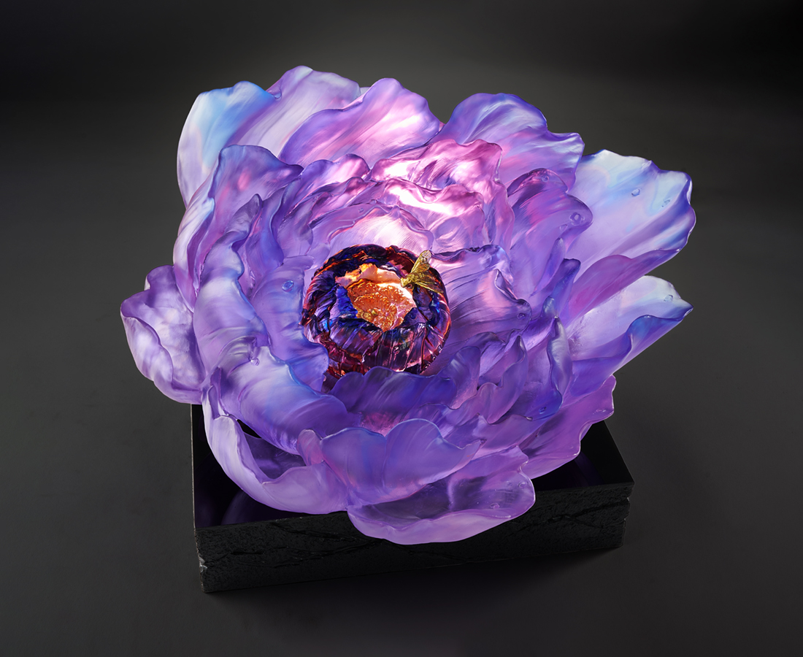
作伴花間弄馥郁
笑看人間染清香
無杯無酒誰人勸
是風是我天香醉

* 底座尺寸：34.8 * 30.6 * 6.5 cm / 重量：20.5 kg
Fragrance from Heaven (with base)
The peony is a species of flower native to Asia, with a rich corolla of petals and a rich color, and is therefore a favorite flower in Chinese culture. Since ancient times, there have been numerous artistic and literary works based on the peony. In Chinese literature, peonies are elegantly referred to as "the fragrance from heaven", and poets describe them as intoxicating at first smell. Such beautiful imagery is the source of inspiration for this work.

編號 | 1594085 | No | 1594085
名稱 | 天香醉 ( 含底座 ) | Name | Fragrance from Heaven (with base)
顏色 | 粉紅紫羅蘭琥紫藍透 + 金箔 | Color | pink, violet, amber, purple, blue, clear
尺寸 | 46.5 * 40 * 27.5 | Size | 46.5 * 40 * 27.5
重量 | 36.0 | Weight | 36.0
限量 | O | Limited Edition | O
售價 | NT$ 264800 | Price | NT$ 264800
 | RMB$ 58850 |  | RMB$ 58850

