六賢圖 | 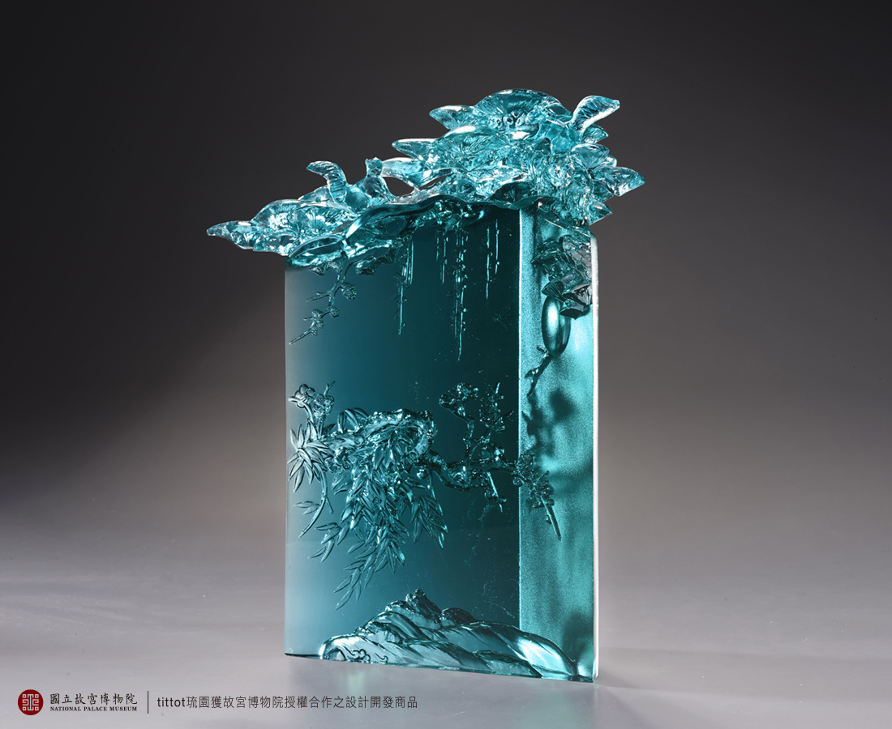
蒼松隱映 瘦竹聲簌
水天共色 明鏡相隨
梅香指路 悠悠五清
人影韜晦 彬彬六賢
清泉碎明月 松竹相交謁
有心遠塵囂 何處不棲身
In ancient Chinese painting, five elements are used to symbolize good character: the pine, the bamboo, the plum, the water and the moon. These are the insights of the ancients from their observations of nature, such as the evergreen pine, the uprightness of the bamboo, the resilience of the plum blossom, the clarity of the water, and the moon reflecting one's innermost being like a mirror. The humans who appreciate the virtues become the sixth element. In collaboration with the National Palace Museum in Taiwan, this work is inspired by the painting "The Five Purities" by Qing Dynasty painter Yun Shouping, deconstructing the flat painting and creating a spatial aesthetic through the refraction of the glazed triangular columns.

編號 | 1594079 | No | 1594079
名稱 | 六賢圖 | Name
顏色 | 青 | Color | cyan
尺寸 | 27.5 * 12 * 32 | Size | 27.5 * 12 * 32
重量 | 8.4 | Weight | 8.4
限量 | O | Limited Edition | O
售價 | NT$ 40800 | Price | NT$ 40800
 | RMB$ 9080 |  | RMB$ 9080

