經久不息 | 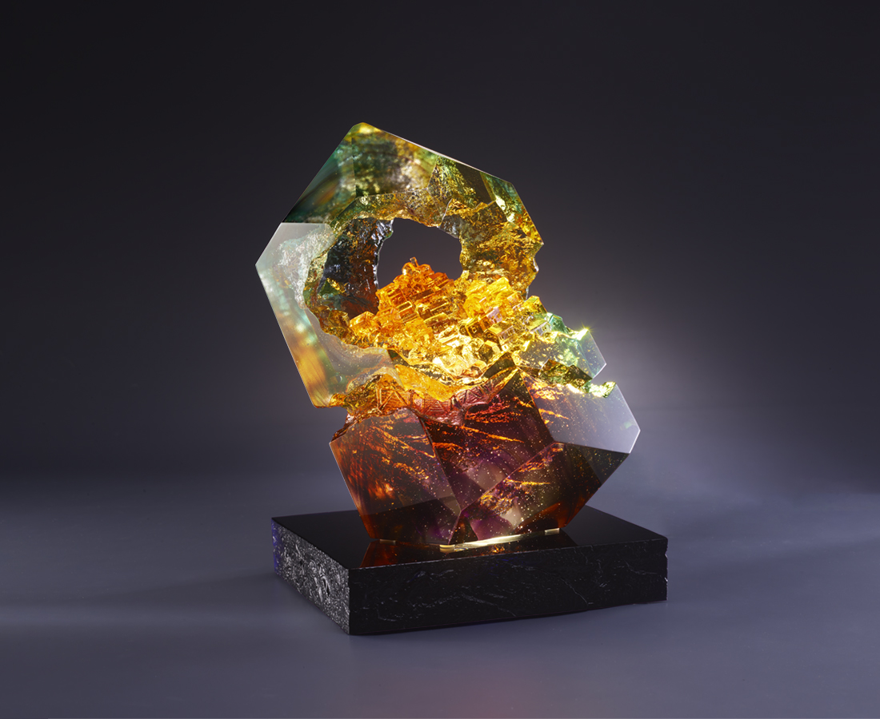
夜來九份璀燦光 金瓜石已入夢鄉
隔山相伴命相繫 空壁回音訴衷腸
繁華不知重金埋 幾度枯榮千年唱
多少人的故事 幾代人的夢想
掌聲響起
經久不息
Jiufen and Jinguashi
Jiufen and Jinguashi, located on the north coast of Taiwan, are famous for their gold mines. After Taiwan's colonial period, this place prospered due to gold mining, but also declined due to the cessation of mining, its significance deep rooted in the Taiwanese history. In 1989, a well-known director made a movie based on the history of the area, which not only attracted a large number of artists and literati, but also transforming the once-declining mining area into a tourist attraction, cultivating new heights in its prosperity. Today, while experts believe there are still plenty of gold mines underneath, the thriving tourist spots on the surface are brightly lit with its new chapters of history ready to be written.

編號 | 1594075 | No | 1594075
名稱 | 經久不息 | Name | Jiufen and Jinguashi
顏色 | 作品：紫琥藍青透 + 金箔 底座：深藍 | Color | art work：purple, amber, blue, cyan, clea
尺寸 | 19.5 * 10.5 * 21.4 c | Size | 19.5 * 10.5 * 21.4 c
重量 | 6.06 | Weight | 6.06
限量 | O | Limited Edition | O
售價 | NT$ 30800 | Price | NT$ 30800
 | RMB$ 7350 |  | RMB$ 7350

