好事在發生 | 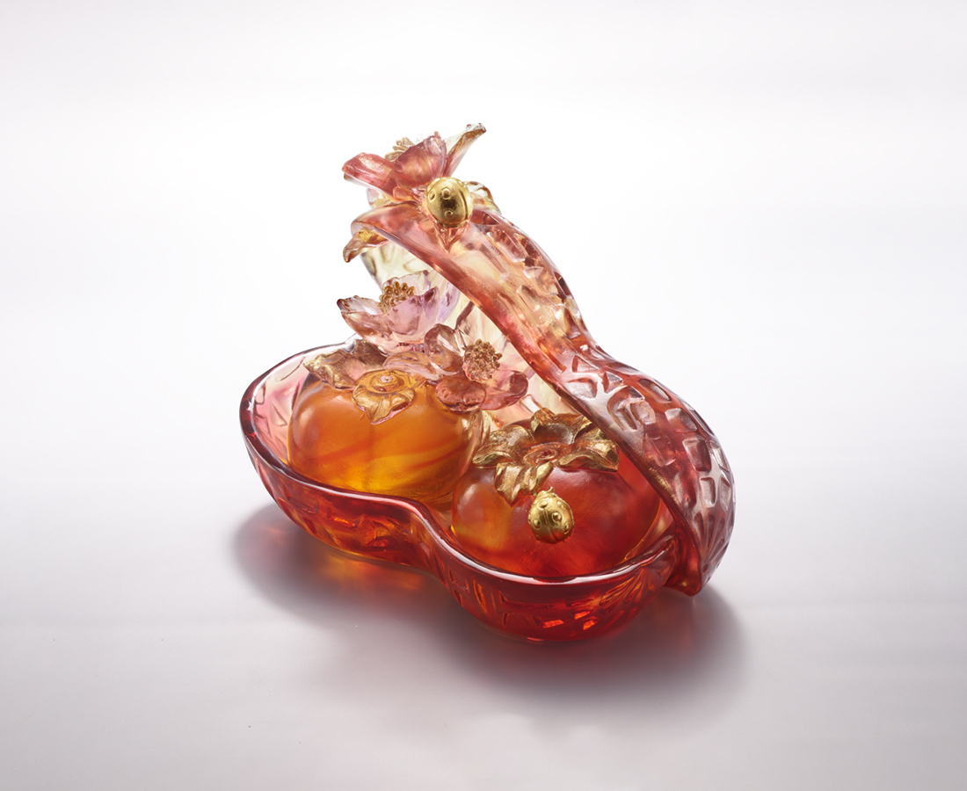
八拜交 群賢聚
循往業 守初志
你我 分甘共苦
喜聞 摘果抱金歸
樂見 好事在發生
Good Things Happen
In Chinese, the persimmon represents good fortune, and the peanut symbolizes immortality and fertility, hence they are often prepared in festivals. The combination of persimmons (pronounced shih) and peanuts (pronounced hua sheng) conveys the auspicious message of "good things happen (pronounced hao shih fa sheng)".

編號 | 1593995 | No | 1593995
名稱 | 好事在發生 | Name | Good Things Happen
顏色 | 紅琥粉紅透 + 金箔 | Color | red, amber, pink, clear + gilding
尺寸 | 17.1 * 10 * 12.3 | Size | 17.1 * 10 * 12.3
重量 | 1.58 | Weight | 1.58
限量 | O | Limited Edition | O
售價 | NT$ 12800 | Price | NT$ 12800
 | RMB$ 3050 |  | RMB$ 3050

