福容天地 | 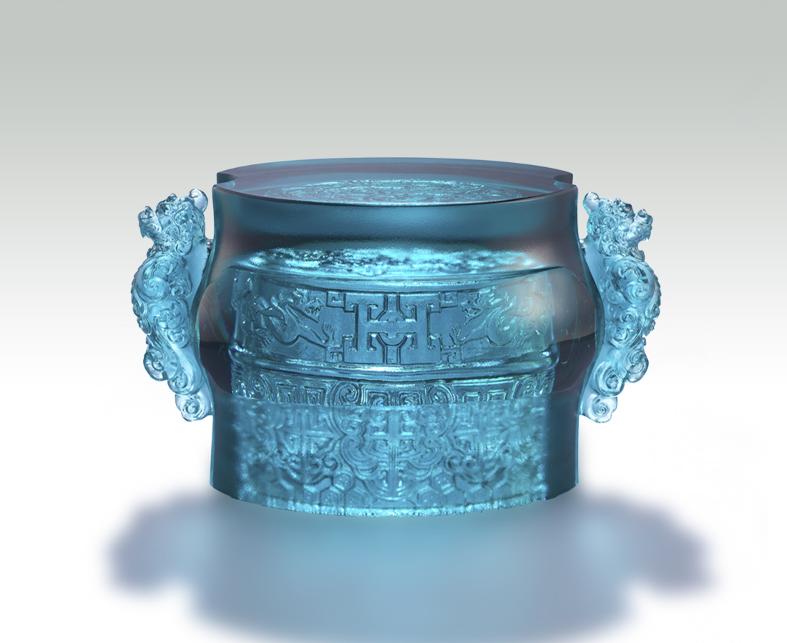
積善積德 匯成運道
聚集得福
歲月更迭 不移其念
千山萬水 不忘其志
人間處處好風景
唯福能容
Fortune
The artwork applies the Chinese cauldron as its overall design. The interior is engraved with intricate Chinese patterns conveying auspiciousness. The outer polishing, on the other hand, faintly shows the inner patterns in a mysterious way of beauty. The Pixiu (ancient Chinese creature symbolizing fortune) relief designs on the sides conveys wealth and prosperity.

編號 | 1593921 | No | 1593921
名稱 | 福容天地 | Name | Fortune
顏色 | 青 | Color | cyan
尺寸 | 16.7 * 10.4 * 10 | Size | 16.7 * 10.4 * 10
重量 | 1.9 | Weight | 1.9
限量 | O | Limited Edition | O
售價 | NT$ 12800 | Price | NT$ 12800
 | RMB$ 2850 |  | RMB$ 2850

