雍容自若 | 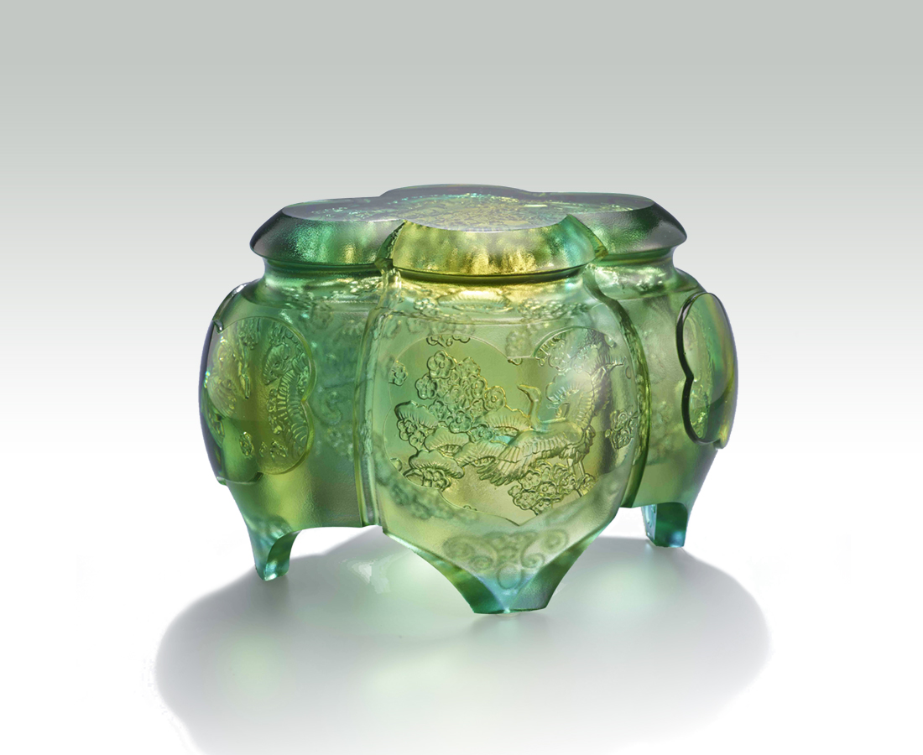
祥鶴展翅
翩翩地在松梅間起舞
是詩意 也是禪意
內斂的自信 渾然天成
時間刻劃於世間的鉅作
就在一念之間
剎那即是永恆之美
Prosperity
The artwork utilizes four petals as the design of vessel. The interior engraved with illustrations of pine, crane, and plum flower conveys infinite vitality. The outer polishing shows faintly the beauty of inner illustrations.

編號 | 1593920 | No | 1593920
名稱 | 雍容自若 | Name | Prosperity
顏色 | 金青綠 | Color | golden, cyan, green
尺寸 | 16.5 * 13.9 * 11 | Size | 16.5 * 13.9 * 11
重量 | 2.0 | Weight | 2.0
限量 | O | Limited Edition | O
售價 | NT$ 13600 | Price | NT$ 13600
 | RMB$ 3050 |  | RMB$ 3050

