山容海納 | 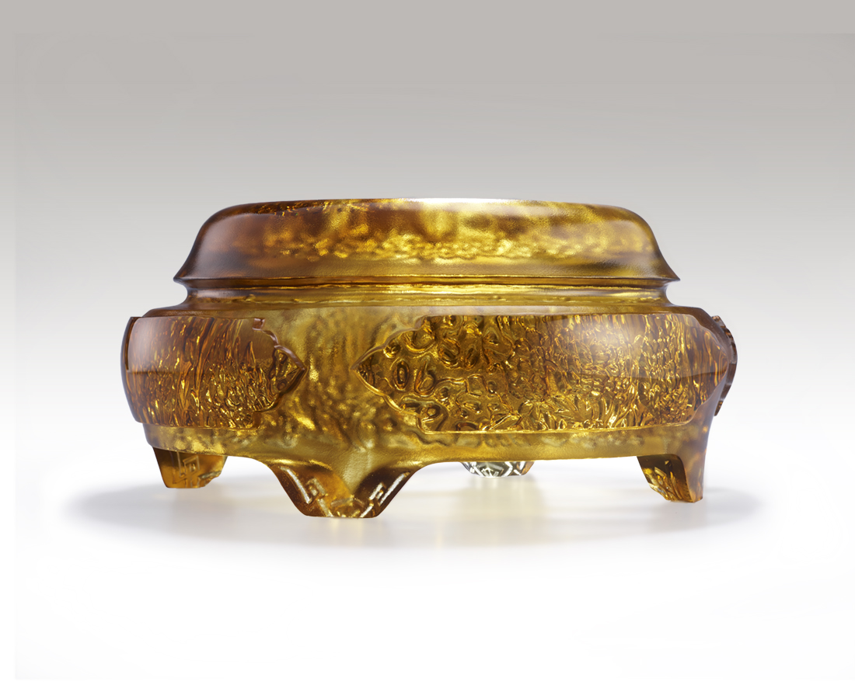
翻閱人生 翻越高山
大器如海 大氣登場
轉眼即是世界
心如芥子 瀟灑如煙
無我 無極限
Longevity
The artwork applies incense burner as its shape. The interior is engraved with intricate designs of the Taihu Stone, flowers, and the Chinese character of longevity. With its outer polishing, the artwork faintly shows the beauty of the inner art from its exterior. The Taihu Stone, after thousands of years of etching, conveys the undeniable power of nature and represents longevity.

編號 | 1593919 | No | 1593919
名稱 | 山容海納 | Name | Longevity
顏色 | 茶金 | Color | tea gold
尺寸 | 18.7 * 18.7 * 9 | Size | 18.7 * 18.7 * 9
重量 | 2.7 | Weight | 2.7
限量 | O | Limited Edition | O
售價 | NT$ 13800 | Price | NT$ 13800
 | RMB$ 3080 |  | RMB$ 3080

