容華富貴 | 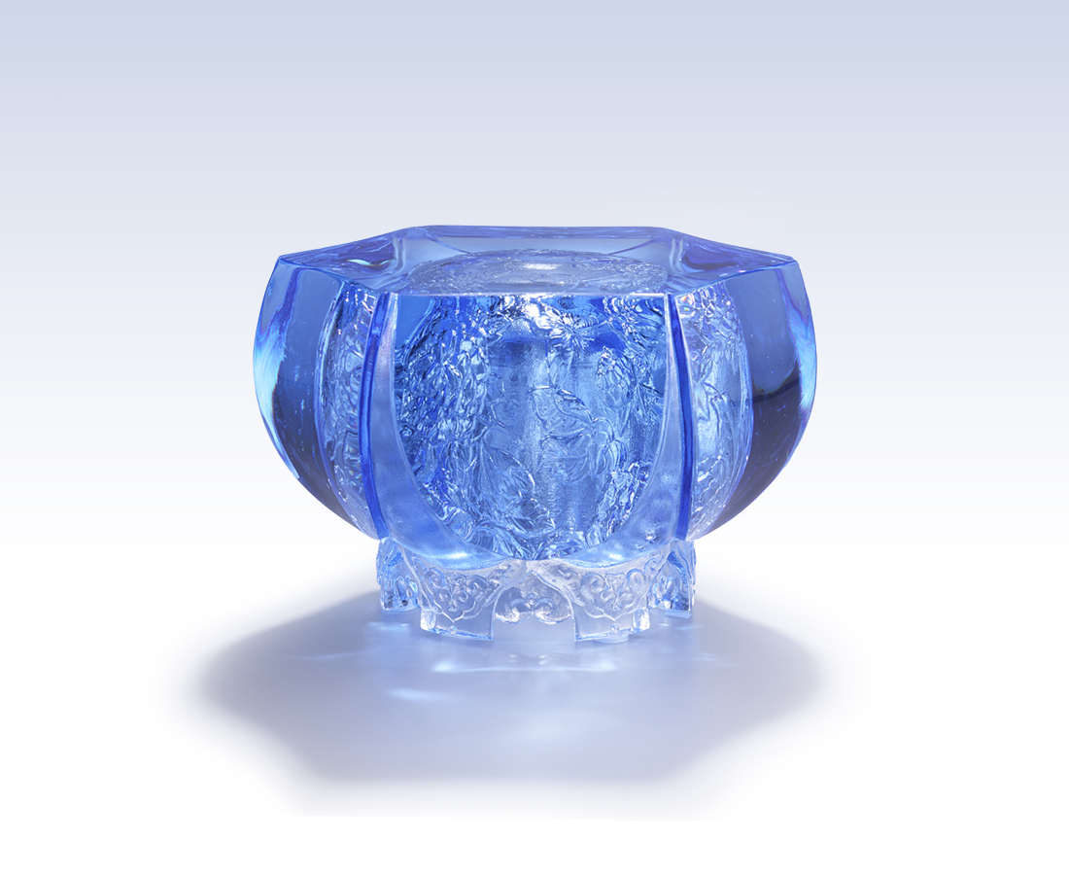
歷練轉化成喜悅
收穫豐碩 如同覓得桃花源
破繭而出 脫胎換骨
風華 不言而喻
自然的和諧 塑造出雋永的丰采
Happiness
The interior of this artwork, engraved with intricate designs of peony and butterfly, emanates wealth and fortune. The outer polishing shows, faintly, the inner beauty of the artwork.

編號 | 1593918 | No | 1593918
名稱 | 容華富貴 | Name | Happiness
顏色 | 淺藍 | Color | Light blue
尺寸 | 11.9 * 11.2 * 8 | Size | 11.9 * 11.2 * 8
重量 | 1.3 | Weight | 1.3
限量 | O | Limited Edition | O
售價 | NT$ 8280 | Price | NT$ 8280
 | RMB$ 1850 |  | RMB$ 1850

