容光煥發 | 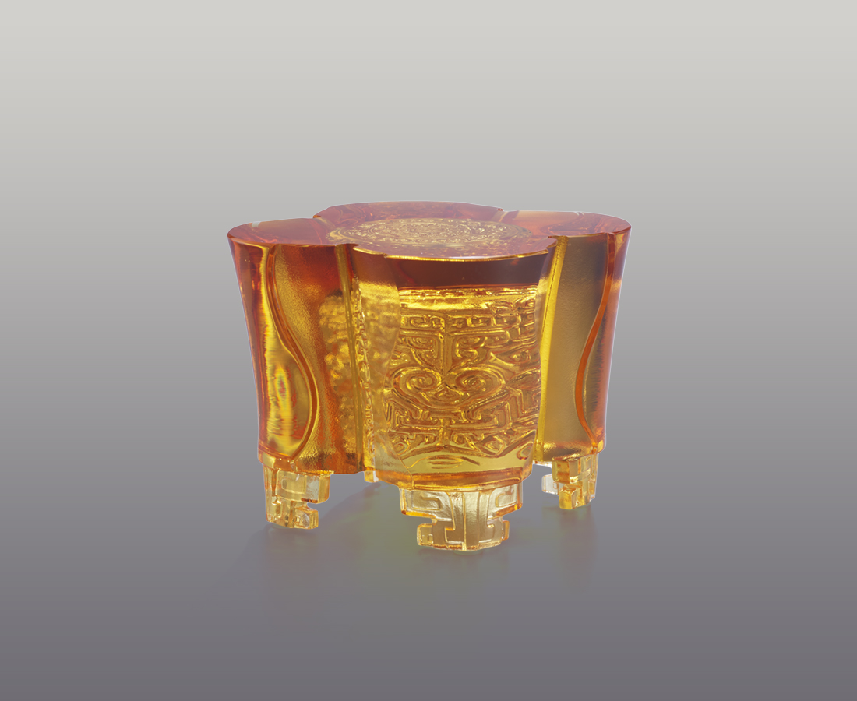
晨曦的光芒 遍照大地
洗滌萬物 豐沛四方
溫暖的力量 給予信心
堅定的目光 鎖定目標
遠方 即在前方
Wealth
The artwork utilizes four petals as the design of vessel. The inner engraving of dragon and cloud patterns convey nobility and prestige. The outer polishing, on the other hand, shows the beauty of the inner illustrations.

編號 | 1593917 | No | 1593917
名稱 | 容光煥發 | Name | Wealth
顏色 | 琥 | Color | amber
尺寸 | 10.8 * 9.4 * 7.8 | Size | 10.8 * 9.4 * 7.8
重量 | 0.85 | Weight | 0.85
限量 | O | Limited Edition | O
售價 | NT$ 6280 | Price | NT$ 6280
 | RMB$ 1400 |  | RMB$ 1400

