金風送閑 | 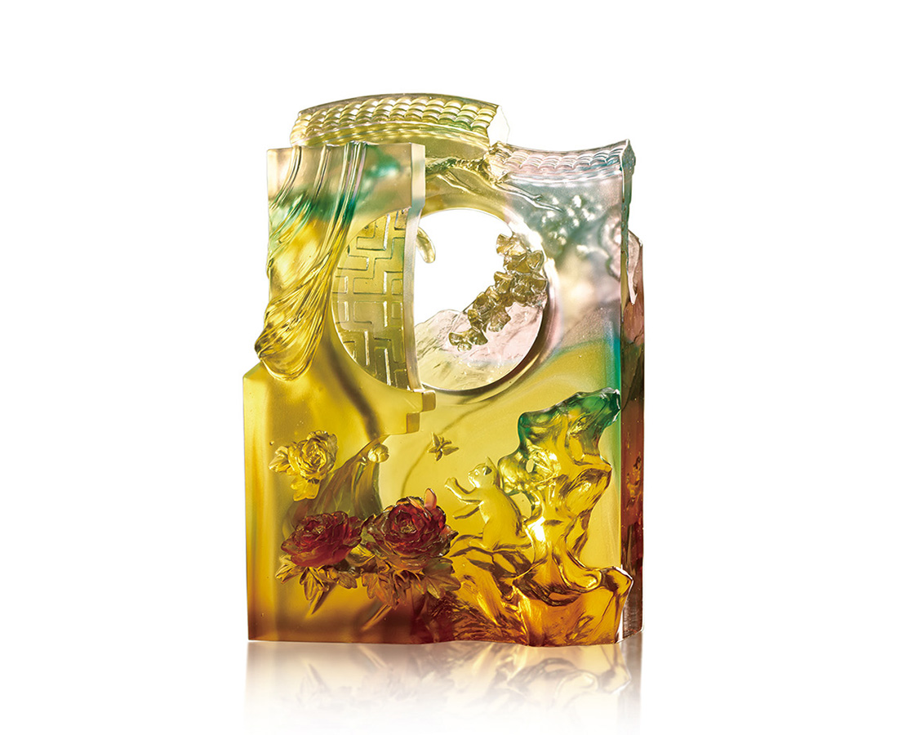
庭院深深深幾重
晶簾閑卷迎秋風
貓捉蝴蝶，牡丹來插花
牆外有牆盡頭在哪
枝頭銀杏斜拋縷縷晴光
灑金入窗，有人午夢正長
Leisure
The artwork imitates Chinese fine brushwork by crystal glass, presenting the elegance of Chinese-garden Courtyard. Multilayered, the design creates a peculiar shade of color and infinite depth of field. With the translucent characteristic and different thickness of crystal glass, the artwork depicts the leisuring time in a Chinese garden.

編號 | 1593897 | No | 1593897
名稱 | 金風送閑 | Name | Leisure
顏色 | 金茶粉紅青紅透+金箔 | Color | golden, brown, pink, cyan, red, clear +
尺寸 | 19 * 11.5 * 27.4 | Size | 19 * 11.5 * 27.4
重量 | 6.2 | Weight | 6.2
限量 | O | Limited Edition | O
售價 | NT$ 46680 | Price | NT$ 46680
 | RMB$ 10380 |  | RMB$ 10380

