歲月耕疊 | 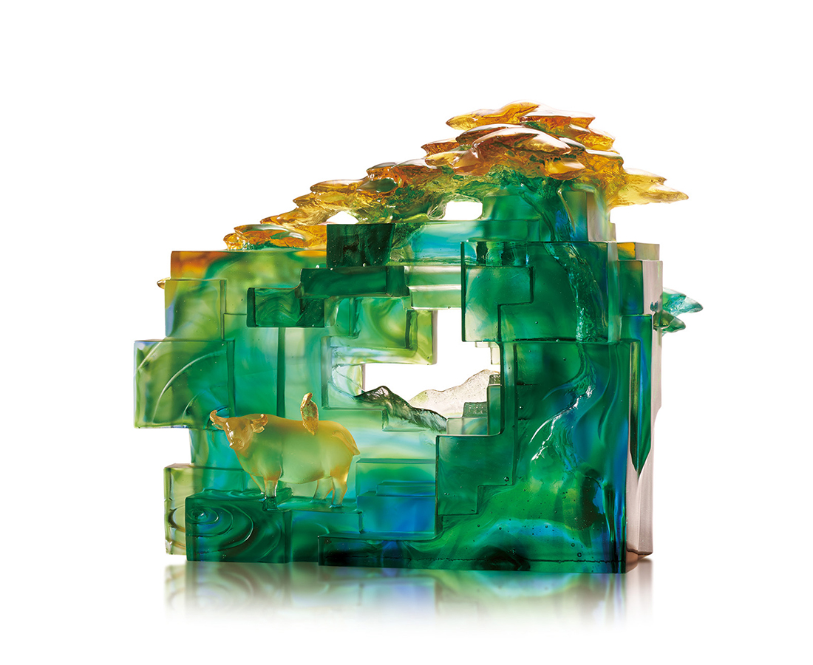
起伏高低，堆疊著耕耘的汗滴
一會兒像爬梯，一會兒像下棋
每塊田地刻留著一次次插秧足跡
遠村深淺曖曖，墟煙濃淡依依
白鷺披上金羽，老牛卸下重犁
掬一池碧水，閑眺蒼蒼翠微
Terraced Field
The artwork imitates oil painting with crystal glass, conveying the coziness of the countryside. Due to the translucent characteristic and different thickness of crystal glass, the designer creates a peculiar shade of color and infinite depth of field, like oil painters composing their works, layer by layer.

編號 | 1593895 | No | 1593895
名稱 | 歲月耕疊 | Name | Terraced Field
顏色 | 藍青綠琥透+金箔 | Color | Blue, cyan, green, amber, clear + gildin
尺寸 | 38 * 18 * 30.5 | Size | 38 * 18 * 30.5
重量 | 18.2 | Weight | 18.2
限量 | O | Limited Edition | O
售價 | NT$ 108000 | Price | NT$ 108000
 | RMB$ 24000 |  | RMB$ 24000

