無窮 | 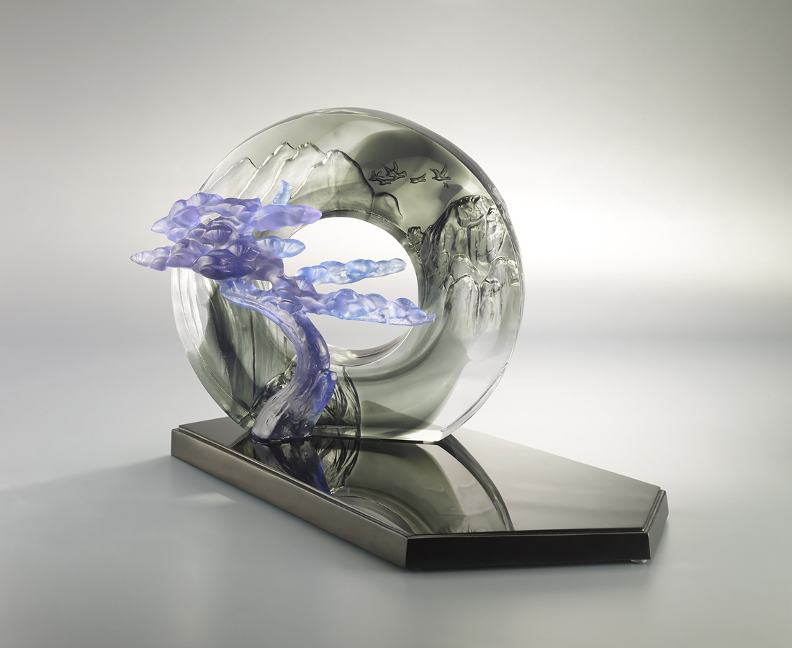
圓 生生不息
方 厚德載物
立 貫通今古
究天人之際
通古今之變
天圓地方 形實而虛
天人合一 胸懷無窮

*本作品含：琉璃作品一件, K9底座一件, 琉璃小山一件
Guest-Greeting Pine
Tittot selects the Guest-Greeting Pine from Mount Huangshan as the artwork’s subject. The pine, with a cave design illustrating beautiful landscape, symbolizes nature greets everyone’s visit. It also indicates its owner should greet everyone with a modest heart and rich knowledge.

編號 | 1593862 | No | 1593862
名稱 | 無窮 | Name | Guest-Greeting Pine
顏色 | 1.紫羅蘭藍灰透 2.藍茶綠透 | Color | 1. violet, blue clear 2.blue, brown, gre
尺寸 | 23 * 8.5 * 19 | Size | 23 * 8.5 * 19
重量 | 3.1 | Weight | 3.1
限量 | O | Limited Edition | O
售價 | NT$ 41900 | Price | NT$ 41900
 | RMB$ 9350 |  | RMB$ 9350

