如數家珍 | 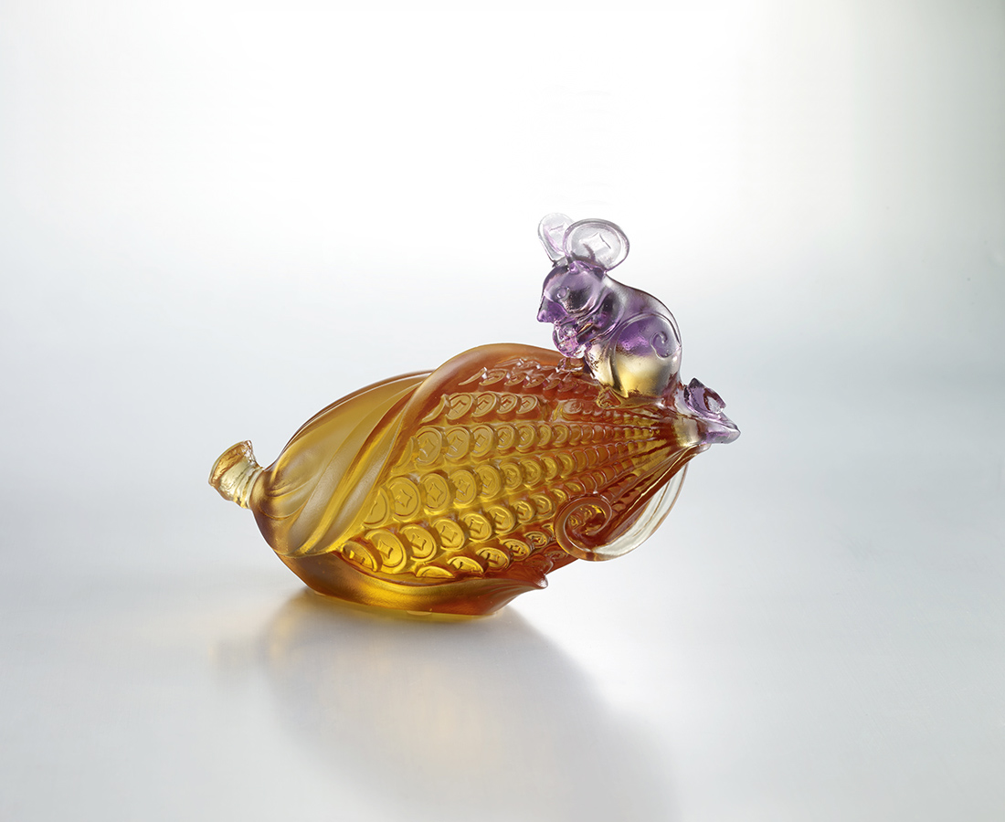
細數身邊所有
了解自己所有
樂在生活 樂於分享
數不盡的真情美好
說不完的人生珍藏
Count Your Blessings
A mouse standing on a piece of corn means that each person has their own treasure; as long as you pay attention to the people and things around you, happiness will not leave your side.

編號 | 1593784 | No | 1593784
名稱 | 如數家珍 | Name | Count Your Blessings
顏色 | 紫金琥 | Color | purple, golden, amber
尺寸 | 14.7 * 6.4 * 10.4 | Size | 14.7 * 6.4 * 10.4
重量 | 0.75 | Weight | 0.75
限量 | X | Limited Edition | X
售價 | NT$ 5980 | Price | NT$ 5980
 | RMB$ 1350 |  | RMB$ 1350

