豁然開朗(下江陵) | 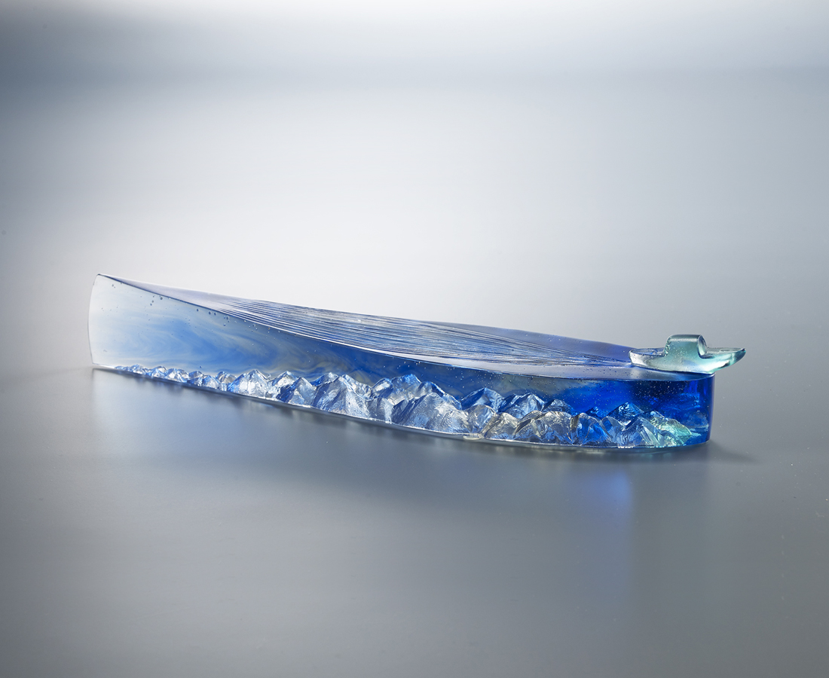
縱是兩岸猿聲
啼不住我瀟灑的心與身
心似奔騰江水
如意運轉
藐視過去的無數艱險
身如一葉輕舟
峰迴路轉
穿過眼前的驚濤駭浪
海闊天空 豁然開朗
輕舟早已穿過萬重山
一路瀟灑 一路成就
The Boat
Its streamlined shape is a symbol of constantly flowing water. The boat follows the course of the river downstream, winding past one mountain after another; and this means that as long as there is a free and unrestrained spirit, obstacles can be overcome.

編號 | 1593777 | No | 1593777
名稱 | 豁然開朗(下江陵) | Name | The Boat
顏色 | 藍青灰透 | Color | blue, cyan, glay, clear
尺寸 | 25.2 * 5.5 * 3.6 | Size | 25.2 * 5.5 * 3.6
重量 | 0.6 | Weight | 0.6
限量 | X | Limited Edition | X
售價 | NT$ 3680 | Price | NT$ 3680
 | RMB$ 820 |  | RMB$ 820

