真愛珍藏(秋夕) | 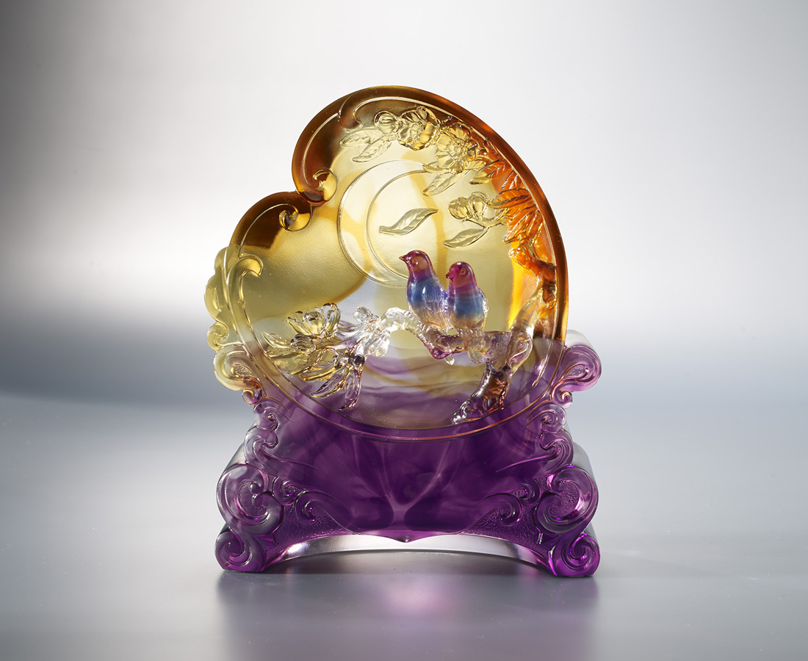
天階夜色涼如水
清冷的夜晚
最適合甜蜜的低語
數著舞動的流光
輕輕依偎著彼此
哪怕明日就要隔著銀河
牽牛織女依舊勾連成一個心
時時刻刻都值得珍藏
大事小事都想與你分享
The Magpie Screen
Through a pair of magpies perching on a screen, Tittot expresses the romantic feelings between lovers, as well as the desire to share with each other and cherish memories.

編號 | 1593776 | No | 1593776
名稱 | 真愛珍藏(秋夕) | Name | The Magpie Screen
顏色 | 藍琥紫透 | Color | blue, amber, purple, clear
尺寸 | 16.1 * 7 * 20 | Size | 16.1 * 7 * 20
重量 | 3.0 | Weight | 3.0
限量 | O | Limited Edition | O
售價 | NT$ 18800 | Price | NT$ 18800
 | RMB$ 4180 |  | RMB$ 4180

