定江山(哥舒歌) | 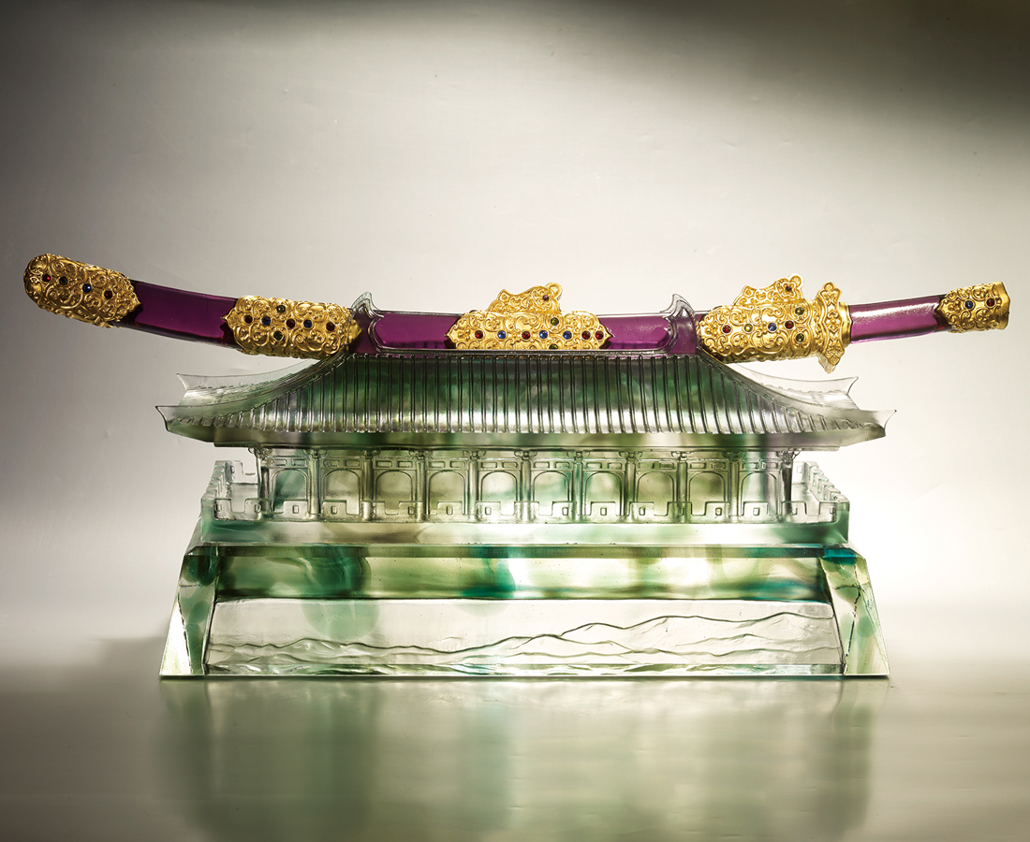
有了胸襟膽識
自能上下萬里都坦蕩浩然
有了遠眺四方的眼界
就可以望見千年萬世的大勢
七星刀 屹立獨尊
問天下英雄誰敵手
昔有曹劉 今日唯我
何人敢攖其鋒
至今窺牧馬
不敢過臨洮
The City Gate
Tittot turns Tang Dynasty frontier poetic imagery into three-dimensional sculpture. The lofty city gate and sword symbolize the army which defends the country, and this can be extended to mean that everyone has to develop and defend their career ambitions.

編號 | 1593775 | No | 1593775
名稱 | 定江山(哥舒歌) | Name | The City Gate
顏色 | 灰青紫透＋金箔 | Color | gray, cyan, purple, clear + gilding
尺寸 | 63 * 21.6 * 24.2 | Size | 63 * 21.6 * 24.2
重量 | 27.0 | Weight | 27.0
限量 | O | Limited Edition | O
售價 | NT$ 258800 | Price | NT$ 258800
 | RMB$ 57500 |  | RMB$ 57500

