情韻(雜詩) | 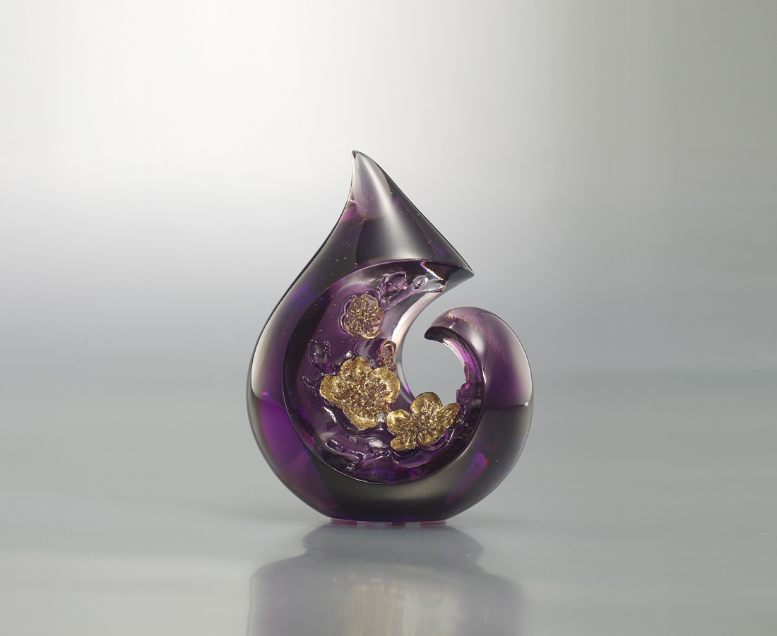
滴滴回憶 點點情誼
是魂牽夢縈的梅
來日 回首窗前
寒梅著花未
有了思念
才能挺向未來的挑戰
正如有了寒
梅花才能在綺窗前盛開
Plum Blossom
Water droplets are symbolic of memories; the blooming plum blossom symbolizes a grand history or aspiration. This shape, which can be held in the hands, means that we must hold onto our precious memories.

編號 | 1593766 | No | 1593766
名稱 | 情韻(雜詩) | Name | Plum Blossom
顏色 | 紫透＋金箔 | Color | purple, amber + gilding
尺寸 | 7.2 * 5.2 * 9 | Size | 7.2 * 5.2 * 9
重量 | 0.34 | Weight | 0.34
限量 | X | Limited Edition | X
售價 | NT$ 3680 | Price | NT$ 3680
 | RMB$ 820 |  | RMB$ 820

