君子之風 | 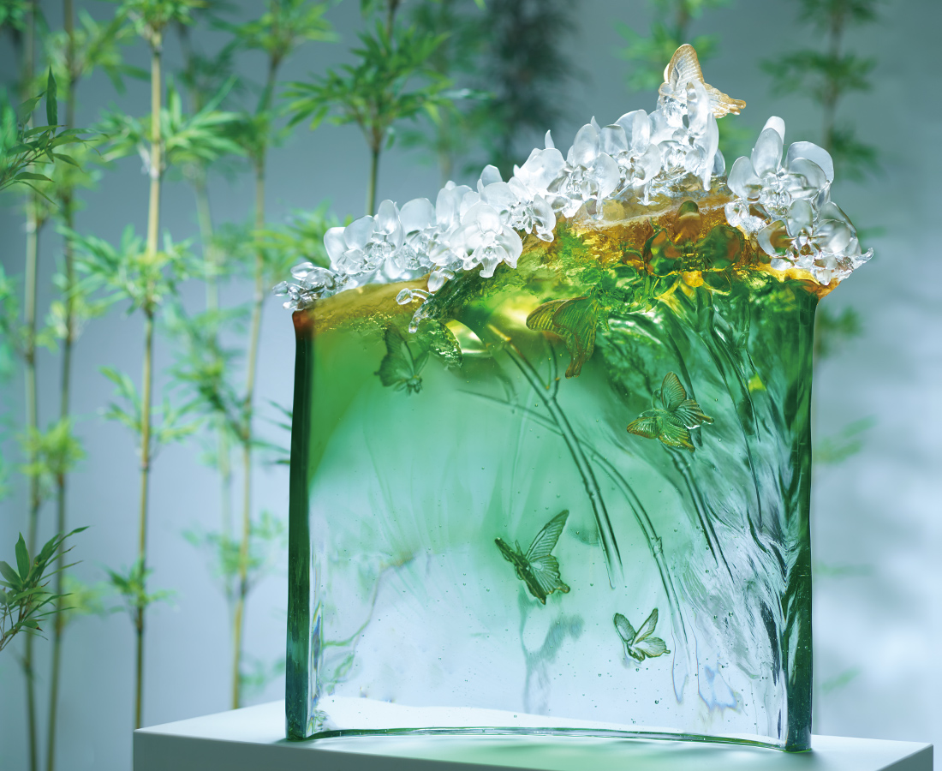
無論是山涯水邊
更或是峭壁幽谷
都要迎風而上
隨著晴光起舞
朵朵 自信含蓄
片片 超凡堅毅
幽香清遠 品節堅貞
迎來
翩然的一山春
Phalaenopsis aphrodite Reichb.f.
The lofty glass base is like the native valley of the orchid, and the gradated polishing is a symbol of the resilience of Taiwan’s Butterfly Orchid, which fears neither wind nor rain, but ultimately is appreciated for the glory of its magnificent resplendence.

編號 | 1593761 | No | 1593761
名稱 | 君子之風 | Name | Phalaenopsis aphrodite Reichb.f.
顏色 | 金琥綠透 | Color | golden, amber, green, clear
尺寸 | 57.8 * 29 * 67 | Size | 57.8 * 29 * 67
重量 | 51.0 | Weight | 51.0
限量 | O | Limited Edition | O
售價 | NT$ 556000 | Price | NT$ 556000
 | RMB$ 123600 |  | RMB$ 123600

