悅色 | 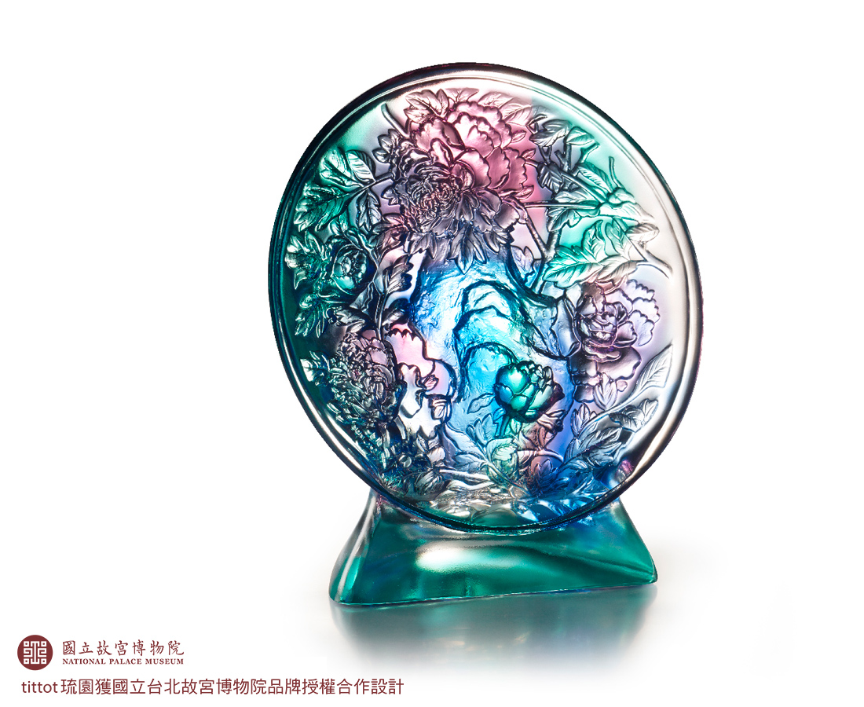
春暖花開時
花長開 人長在
照花前後鏡
花面交相映
蛾眉花顏 月影團圓
Mirror-Shaped Décor
The bronze mirrors in ancient time often had various decorations on them. Tittot utilized intaglio carving and burnishing techniques to integrate the peony painting, one of the collections in National Palace Museum, and transform it into a new piece of home décor.

編號 | 1593760 | No | 1593760
名稱 | 悅色 | Name | Mirror-Shaped Décor
顏色 | 藍紫青透 | Color | blue, purple, cyan, clear
尺寸 | 23.3 * 12.6 * 25.5 | Size | 23.3 * 12.6 * 25.5
重量 | 4.1 | Weight | 4.1
限量 | O | Limited Edition | O
售價 | NT$ 25800 | Price | NT$ 25800
 | RMB$ 5730 |  | RMB$ 5730

