福報如意 | 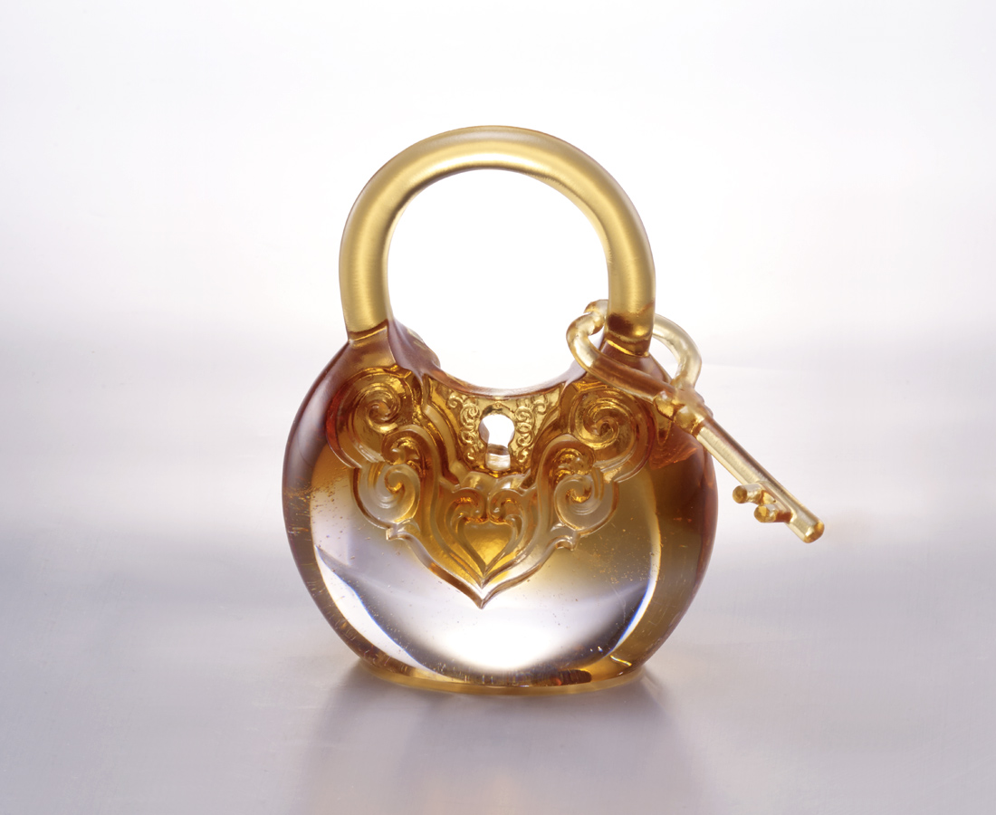
開門迎福
如意常駐
心中天地寬
福報自敲門
Ruyi Lock
Tittot re-castes the modern paperweight by the inspired elements of lock, gourd and Ruyi to make the image of keeping good luck by your side.

編號 | 1593732 | No | 1593732
名稱 | 福報如意 | Name | Ruyi Lock
顏色 | 粉琥 | Color | pink, amber
尺寸 | 8.2 * 5 * 10.5 | Size | 8.2 * 5 * 10.5
重量 | 0.45 | Weight | 0.45
限量 | X | Limited Edition | X
售價 | NT$ 6280 | Price | NT$ 6280
 | RMB$ 1400 |  | RMB$ 1400

