松壽如意 | 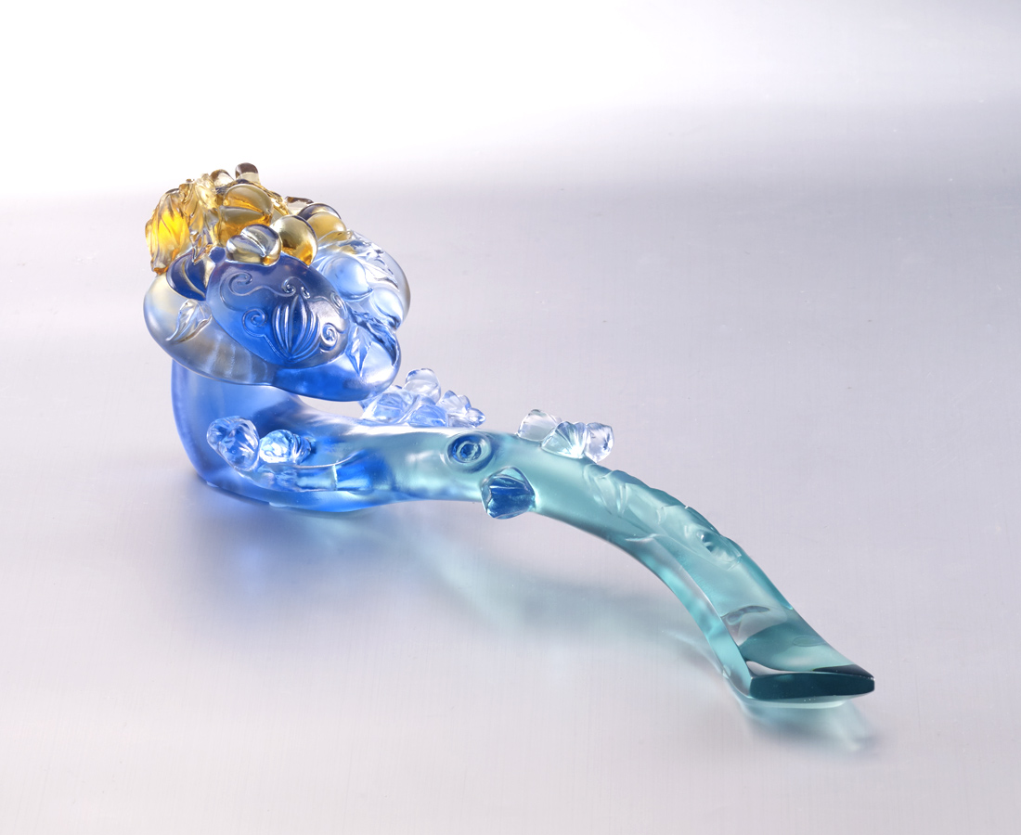
松柏長青
天增歲月人增壽
美意延年
一身皆如意
Pine Ruyi
In the Chinese culture, pine trees and peaches symbolize health and longevity. Tittot makes the Ruyi with the pine and the peach, wishing everybody health.

編號 | 1593725 | No | 1593725
名稱 | 松壽如意 | Name | Pine Ruyi
顏色 | 藍青琥透 | Color | blue, cyan, amber, clear
尺寸 | 27.3 * 8.9 * 8.8 | Size | 27.3 * 8.9 * 8.8
重量 | 0.76 | Weight | 0.76
限量 | O | Limited Edition | O
售價 | NT$ 15800 | Price | NT$ 15800
 | RMB$ 3510 |  | RMB$ 3510

