凝靜 | 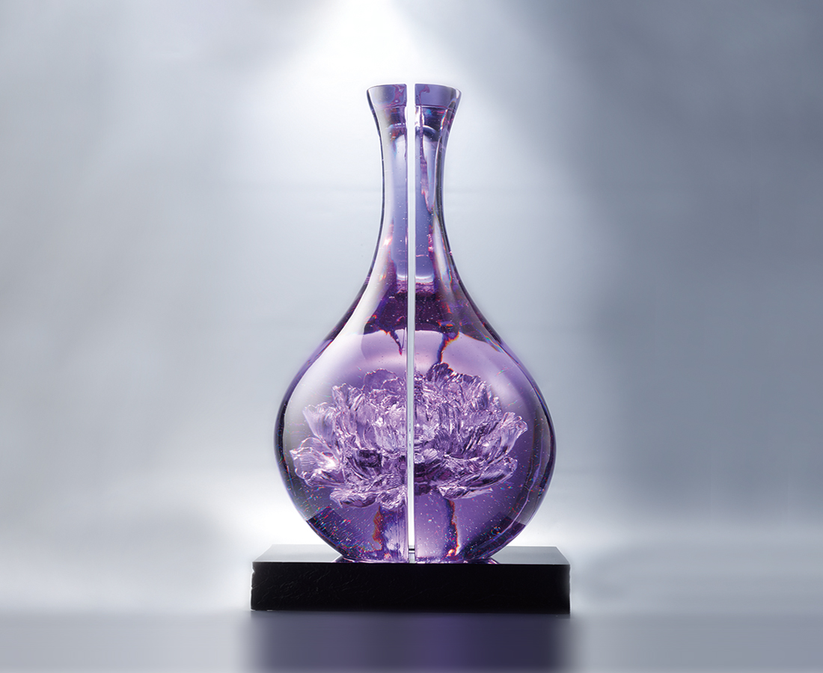
凝視 這一份美
含蓄而雍容
真正的奢華
由內而外
Peony Flower in Bottle
Tittot uses lazurite’s transparent property to give a new interpretation of the beauty of Peony Flower, a breakthrough of traditional concept, presenting confidence and persistence on handicraft art.

編號 | 1593710 | No | 1593710
名稱 | 凝靜 | Name | Peony Flower in Bottle
顏色 | 紫透 | Color | purple, clear
尺寸 | 28 * 26.4 * 49.2 | Size | 28 * 26.4 * 49.2
重量 | 37.3 | Weight | 37.3
限量 | O | Limited Edition | O
售價 | NT$ 168000 | Price | NT$ 168000
 | RMB$ 37500 |  | RMB$ 37500

