韶華天成 | 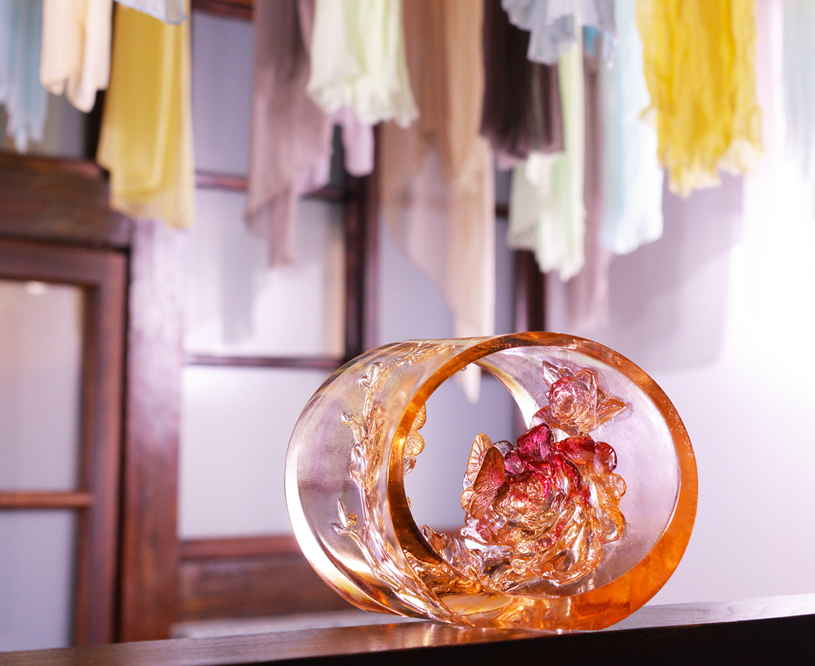
自然而然 無須外求
但看我內心馥郁
自成青春氣象
Peony Flower Ring
Tittot makes the ring to present the delicacy of dewaxing casting art, with double-side design to present the 3D beauty of Peony Flower.

編號 | 1593707 | No | 1593707
名稱 | 韶華天成 | Name | Peony Flower Ring
顏色 | 紅紫琥粉透＋金箔 | Color | red, purple, amber, pink, clear + gold
尺寸 | 21 * 8.4 * 13.3 | Size | 21 * 8.4 * 13.3
重量 | 1.25 | Weight | 1.25
限量 | O | Limited Edition | O
售價 | NT$ 13800 | Price | NT$ 13800
 | RMB$ 3070 |  | RMB$ 3070

