圓滿榮華 | 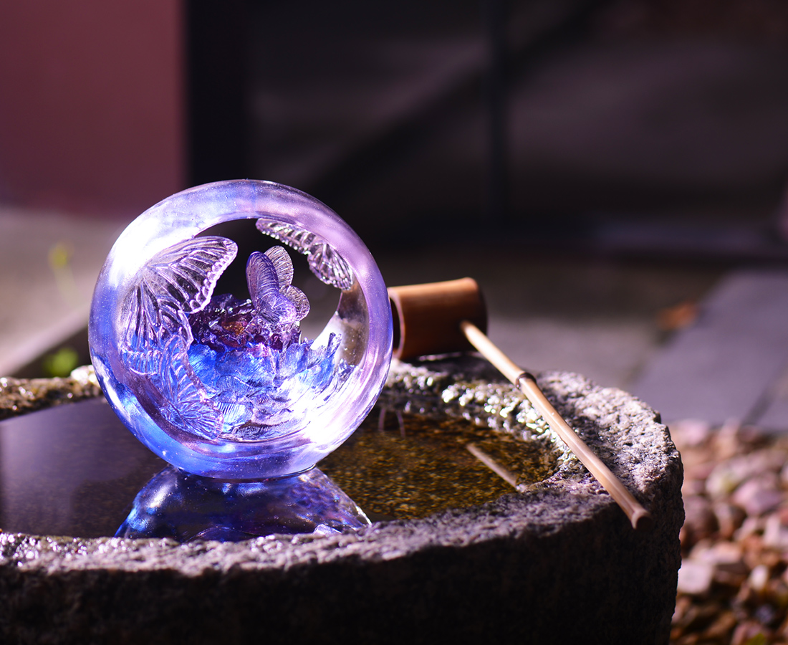
事虛心
人真誠
事事圓滿
好事成雙
Peony Flower Globe
The openwork containing a Peony Flower inside seems a well-cultivated person naturally attracting admiration of other people.

編號 | 1593706 | No | 1593706
名稱 | 圓滿榮華 | Name | Peony Flower Globe
顏色 | 藍紫粉透＋金箔 | Color | blue, purple, pink, clear + gold
尺寸 | 17.1 * 16 * 16.2 | Size | 17.1 * 16 * 16.2
重量 | 3.1 | Weight | 3.1
限量 | O | Limited Edition | O
售價 | NT$ 28950 | Price | NT$ 28950
 | RMB$ 6450 |  | RMB$ 6450

