榮華在握 | 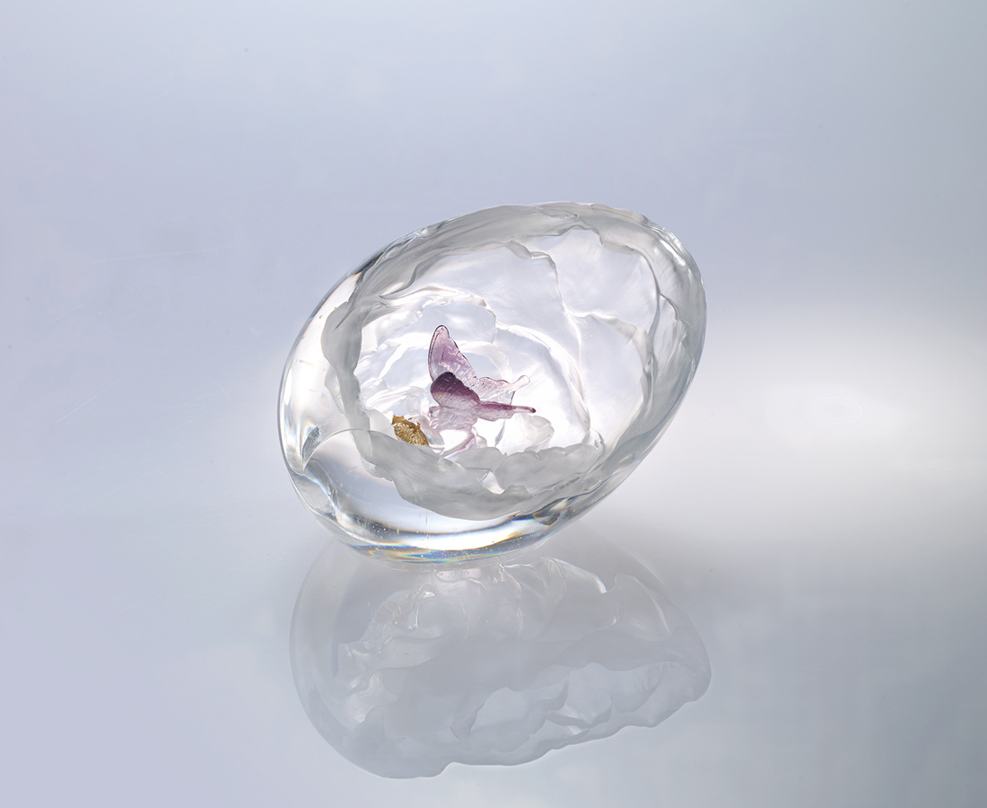
重瓣含蓄
凝郁著一縷幽香
將榮華握於掌中
是自然天成的貴氣迎人

Peony Flower in Palm
Tittot overturns the common image of Peony Flower in brilliant color. The transparent Peony Flower presents the beauty of purity, discerning the tranquil nobility of Peony Flower.

編號 | 1593702 | No | 1593702
名稱 | 榮華在握 | Name | Peony Flower in Palm
顏色 | 透＋金箔 | Color | clear + gold
尺寸 | 14.2 * 10.8 * 10.3 | Size | 14.2 * 10.8 * 10.3
重量 | 1.42 | Weight | 1.42
限量 | X | Limited Edition | X
售價 | NT$ 7250 | Price | NT$ 7250
 | RMB$ 1610 |  | RMB$ 1610

