富貴傳香 | 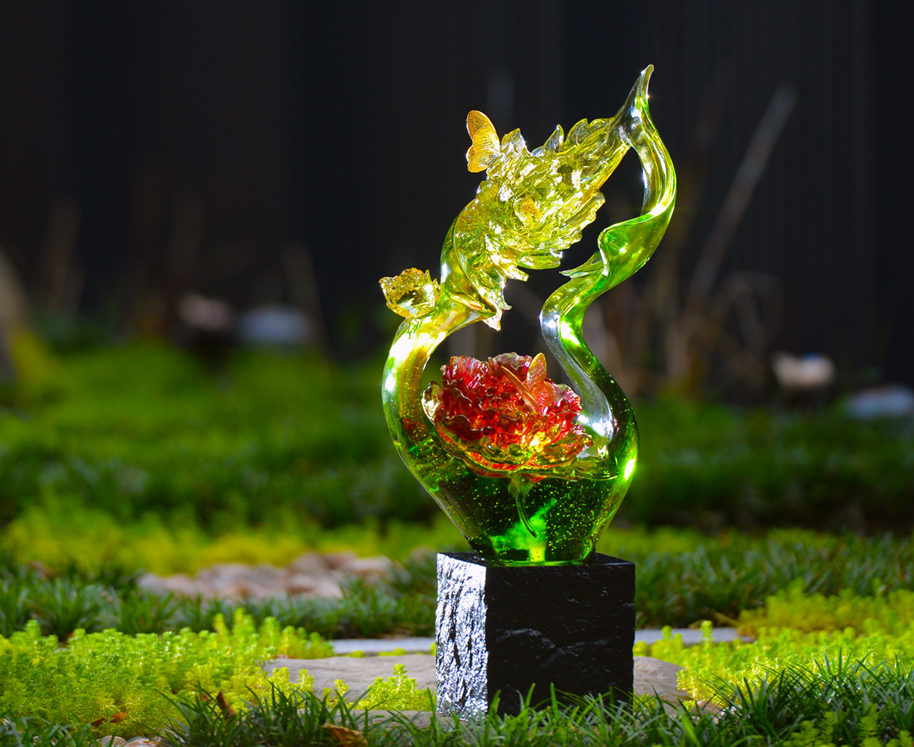
自信 綽約
如歌 如舞
在每一個富貴時節
自然散發
Dancing Peony Flower
Tittot makes a breakthrough of traditional themes of Peony Flower art, using plenty of curves to present a lively look of the flowers, conveying a wealthy and graceful image.

編號 | 1593694 | No | 1593694
名稱 | 富貴傳香 | Name | Dancing Peony Flower
顏色 | 琥綠紅透＋金箔 | Color | amber, green, red, clear + gold
尺寸 | 28 * 20.4 * 50 | Size | 28 * 20.4 * 50
重量 | 13.2 | Weight | 13.2
限量 | O | Limited Edition | O
售價 | NT$ 94400 | Price | NT$ 94400
 | RMB$ 21000 |  | RMB$ 21000

