四喜 | 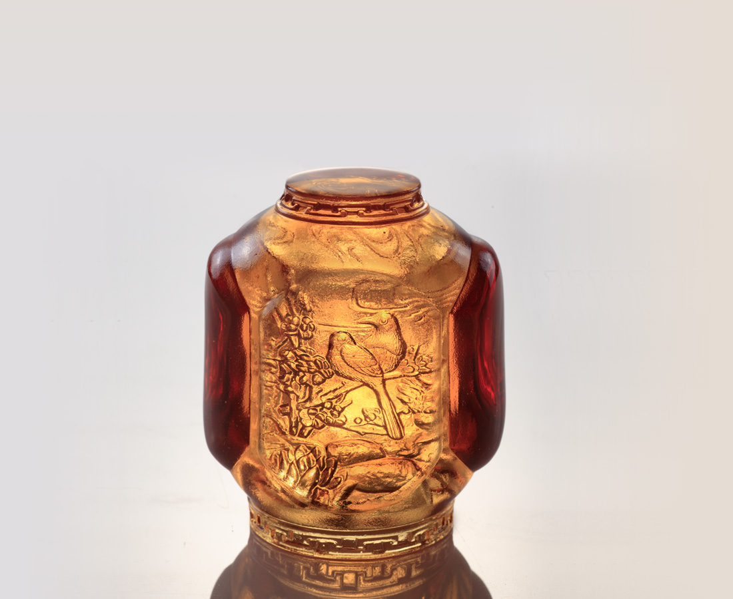
久旱逢甘雨
洞房花燭夜
他鄉遇故知
金榜題名時
Lantern Paperweight
Tittot made the lantern as a paperweight, where its pattern on the top refers to four things that ancients believed worthy of happiness: good weather, get married, union with friends, smooth work.Use it to wish everyone can be smooth and happy in his life.

編號 | 1593634 | No | 1593634
名稱 | 四喜 | Name | Lantern Paperweight
顏色 | 琥 | Color | amber
尺寸 | 7 * 7 * 8.5 | Size | 7 * 7 * 8.5
重量 | 0.49 | Weight | 0.49
限量 | X | Limited Edition | X
售價 | NT$ 4980 | Price | NT$ 4980
 | RMB$ 1110 |  | RMB$ 1110

