喫茶 | 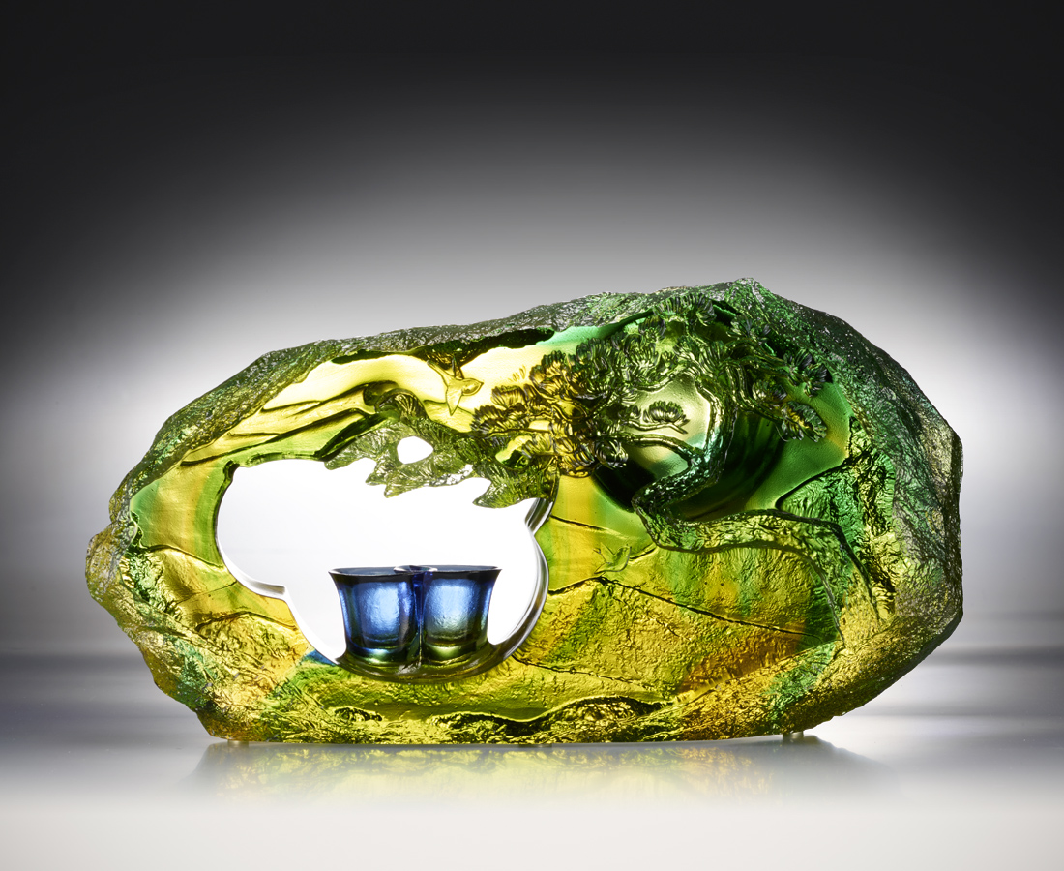
虛懷若壺 湖納山河
鏡水映月 過水無痕
無論天地變幻 無論陰晴圓缺
或是悲歡離合 或是春風得意
總如一輪明月 總如一縷清風
保有心中一縷輕香
喫茶 共賞
Compotation in the Moonlight
Chinese ancient work The Classic of Tea is the world's first tea-themed professional books. It holds that the tea can purify the body so that it is a symbol of noble character. Starting with elegant Chinese paintings, the work creates a situation as if we are together with friends under the pines and enjoy the moon while drinking, without competition inside naturally.

編號 | 1593586 | No | 1593586
名稱 | 喫茶 | Name | Compotation in the Moonlight
顏色 | 綠藍透 | Color | green, blue, clear
尺寸 | 27.5 * 6.5 * 14.5 | Size | 27.5 * 6.5 * 14.5
重量 | 3.45 | Weight | 3.45
限量 | O | Limited Edition | O
售價 | NT$ 22800 | Price | NT$ 22800
 | RMB$ 5070 |  | RMB$ 5070

