自若香 | 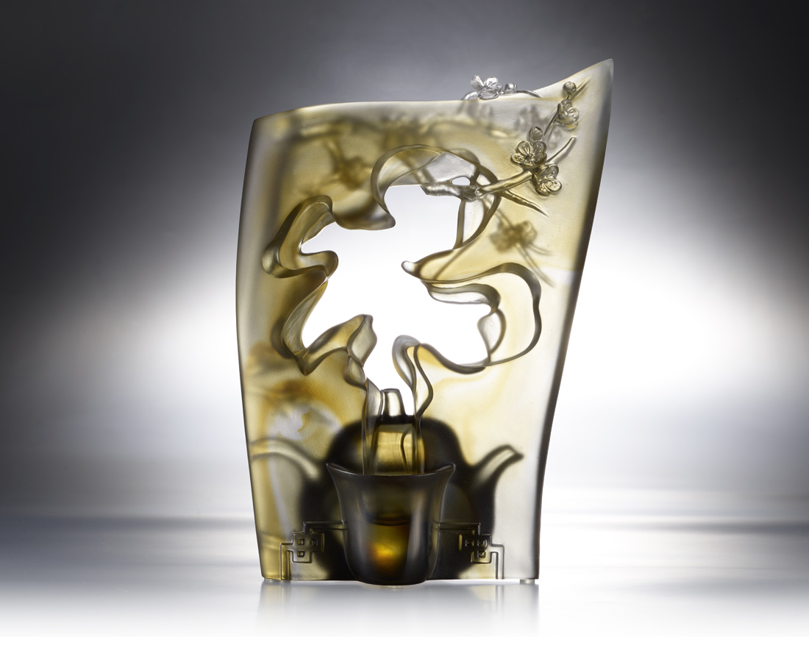
空杯不擁茶滋味 滿壺更懂餘韻香
望盡凌雲三里煙 層層裊裊鋪天地
但見貞觀又開元 其實盛世百樣景
歸來且把梅花嗅 也無風雨也無晴
Tea Aroma
Smelling Cup is a special design of Taiwan tea art. After pouring tea in the cup, people do not drink it but experience and enjoy the sense of smell by using tall and thin teacups to condense tea aroma. With the same tea, everyone's feelings are not the same. Therefore, the work molds a shape to make aroma waft through it in a hollowed-out way. The scenery everyone sees through the hollow is also different.

編號 | 1593585 | No | 1593585
名稱 | 自若香 | Name | Tea Aroma
顏色 | 茶灰 | Color | brown , gray
尺寸 | 16 * 7.3 * 22.5 | Size | 16 * 7.3 * 22.5
重量 | 1.63 | Weight | 1.63
限量 | X | Limited Edition | X
售價 | NT$ 13800 | Price | NT$ 13800
 | RMB$ 3070 |  | RMB$ 3070

