堅毅 | 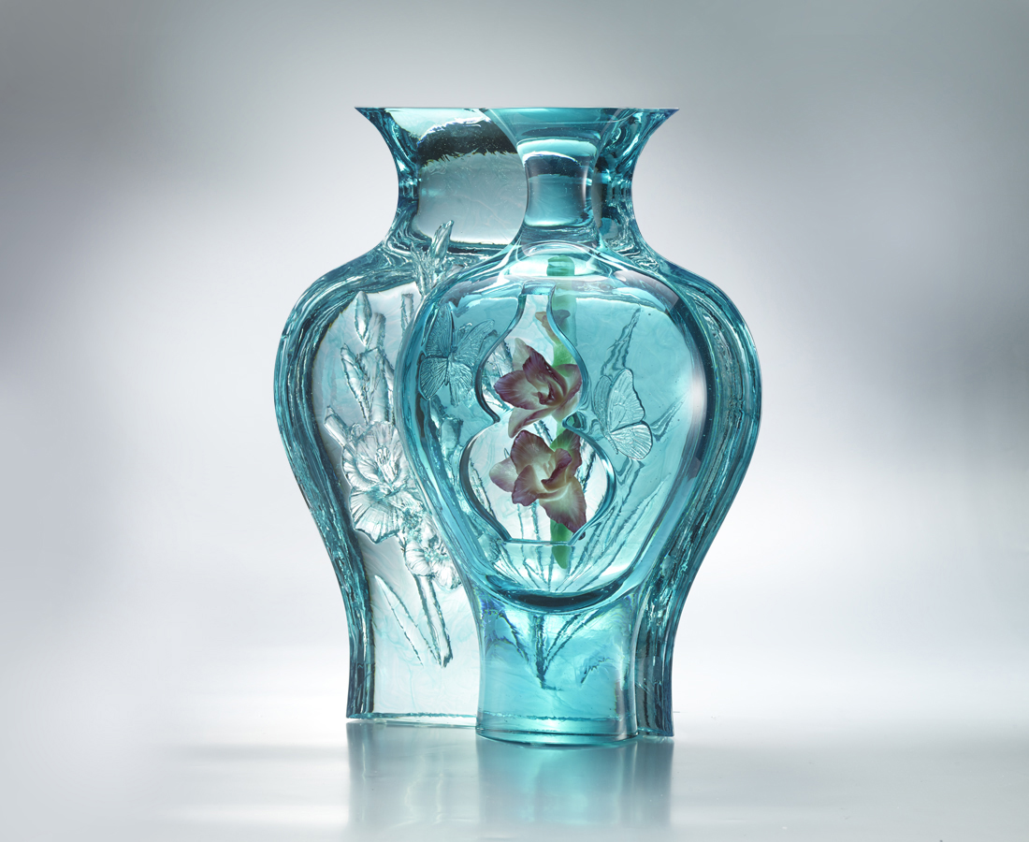
堅貞之心
釀圓滿之味
我心坦然
馨香 翩然紛飛
福祿 自來相合
Gladiolus
Tittot has expressed an image of a gladiolus flower going beyond the vase and stretching to the sky with hollow out, powder sinter and many other glass techniques that showcase Tittot’s persistence toward art creation and encourage everyone to carry on to achieve their own success.

編號 | 1593471 | No | 1593471
名稱 | 堅毅 | Name | Gladiolus
顏色 | 青金紅綠透 | Color | cyan ,golden ,red ,green ,clear
尺寸 | 30 * 18 * 39 | Size | 30 * 18 * 39
重量 | 18.5 | Weight | 18.5
限量 | O | Limited Edition | O
售價 | NT$ 66600 | Price | NT$ 66600
 | RMB$ 14800 |  | RMB$ 14800

