好合 | 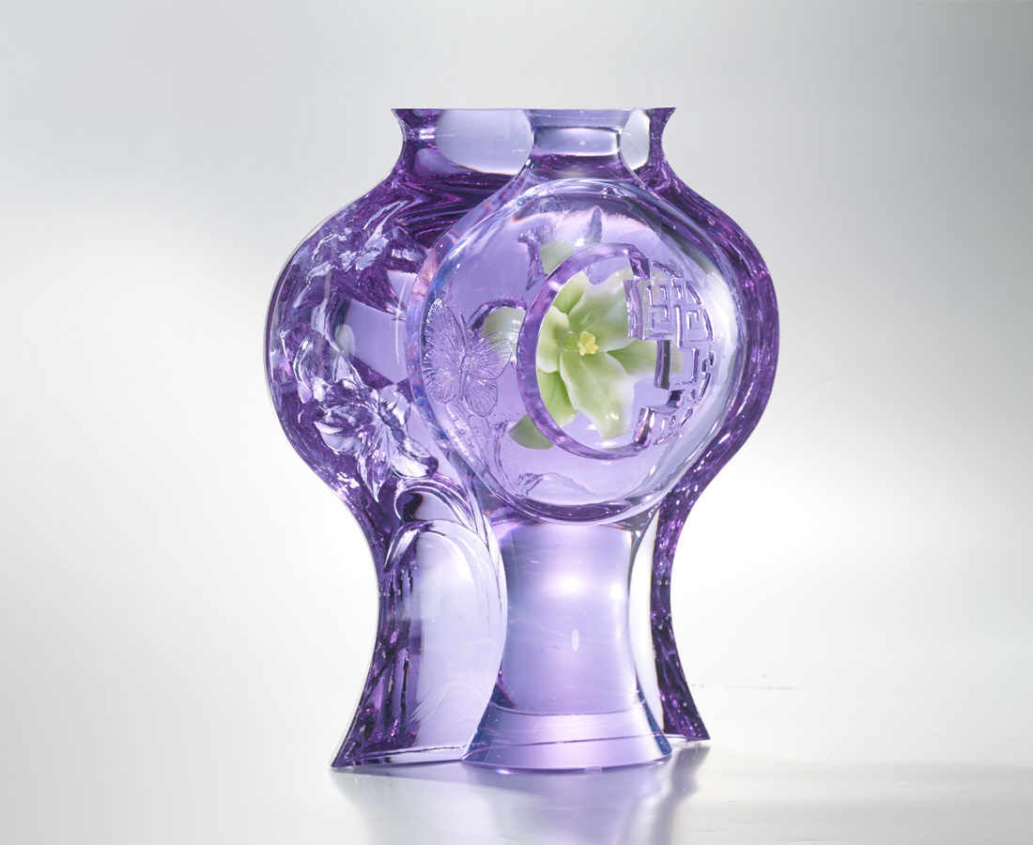
在層層疊疊中
找到高聲吶喊的關鍵
把寬廣心胸 前呼後應
把甜蜜滋味 細細探索
就能昂然直立
就能百福自臻
An image of lilies blooming inside a traditional Chinese vase was developed with modern powder sinter technique. Tittot opens a window full of fantasy and dreams through creative and intriguing ideas that are deeply rooted in Chinese traditional culture.

編號 | 1593470 | No | 1593470
名稱 | 好合 | Name
顏色 | 紫羅蘭綠黃紅透 | Color
尺寸 | 29.5 * 18 * 34 | Size | 29.5 * 18 * 34
重量 | 15.0 | Weight | 15.0
限量 | O | Limited Edition | O
售價 | NT$ 59800 | Price | NT$ 59800
 | RMB$ 13290 |  | RMB$ 13290

