桃花舞春風 | 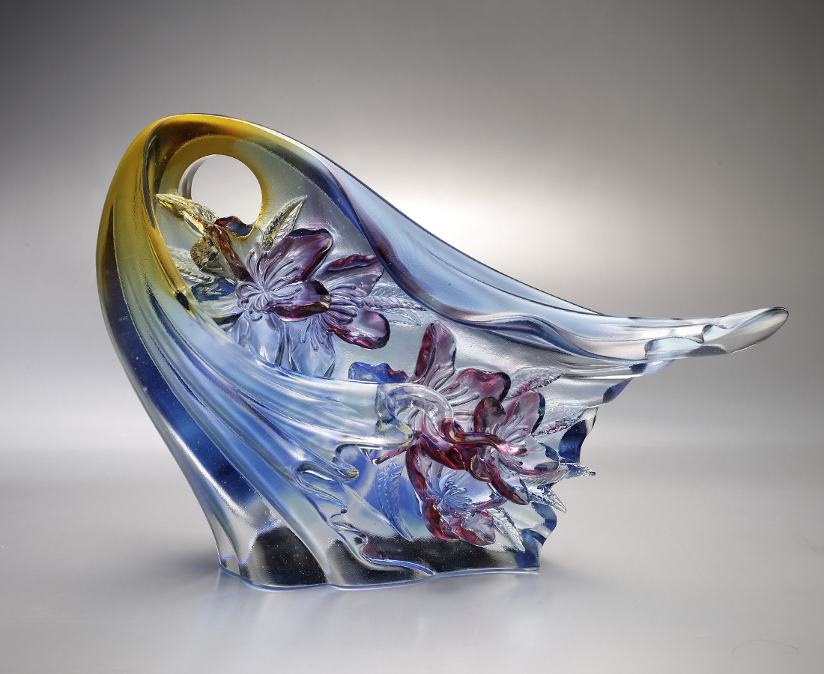
跨越冬天的寒冷
才有在春天綻放的資格
經過等待的堅持
芬芳的幸福終將滿開
約定成喜悅的美景
是開創未來的期待
Peach Blossom Dancing in the Spring Breeze
This artwork is inspired by the Fujian dialect song, “Wang Chun Feng“ which means expecting the spring breeze. The lyrics of the song is about the youth and love of a maiden that could also symbolizes the diligent and energetic Taiwanese are working hard and for the future even in the difficult time.

編號 | 1593298 | No | 1593298
名稱 | 桃花舞春風 | Name | Peach Blossom Dancing in the Spring Breeze
顏色 | 藍青紅紫琥透 | Color | null
尺寸 | 8.8 * 30.9 * 20.5 | Size | 8.8 * 30.9 * 20.5
重量 | 4.52 | Weight | 4.52
限量 | O | Limited Edition | O
售價 | NT$ 29480 | Price | NT$ 29480
 | RMB$ 5950 |  | RMB$ 5950

