桃舞春風 | 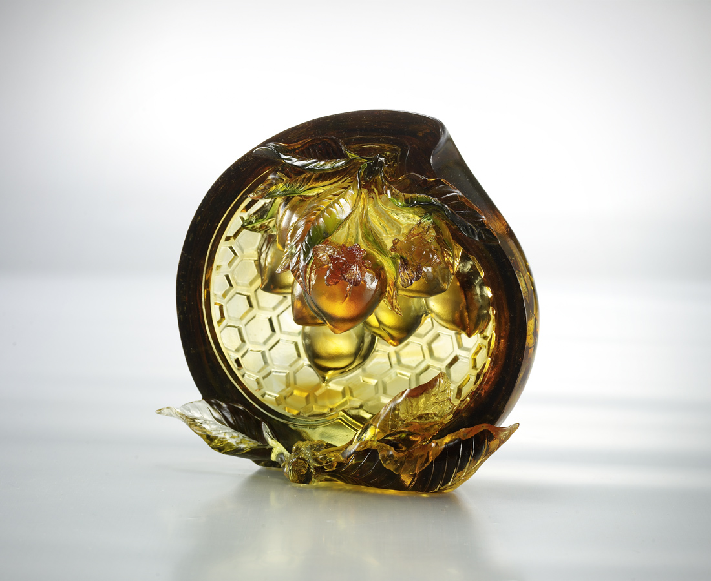
上下拍動 渾身是勁
不計辛勤 只想桃舞春風
不分多少 只享情誼芬芳
滿滿豐收 四方飛來
Peaches Dancing with the Spring Breeze
Up and down, its vigor knows no end Mindless of the hardship Its only desire is to dance with the soft breeze Be it many or few, it delights in the fragrance of emotions The grand harvest comes from all directions

編號 | 1593151 | No | 1593151
名稱 | 桃舞春風 | Name | Peaches Dancing with the Spring Breeze
顏色 | 粉紅透琥綠紫 / 琥綠紫透 | Color
尺寸 | 13*16.5*15 | Size | 13*16.5*15
重量 | 2.6 | Weight | 2.6
限量 | X | Limited Edition | X
售價 | NT$ 18800 | Price | NT$ 18800
 | RMB$ 4170 |  | RMB$ 4170

