願成 | 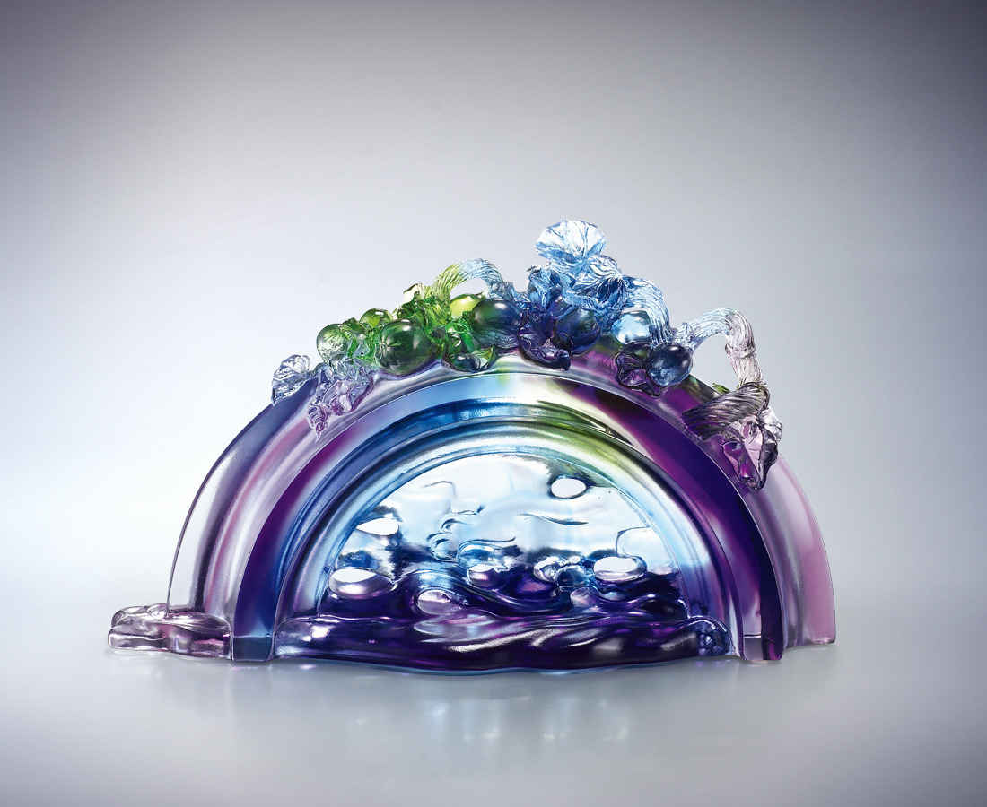
走出繁忙 穿過水
進入澄澈堅定的理想
走出期待 越過橋
進入綠意蓬發的天地
As Wish Comes True
Adieu, hectic headache …tread through water my confusion cleansed Seeing my path from end to end Adios, expectation desperation, …cross the bridge I do To pasture green where wish comes true

編號 | 1592656 | No | 1592656
名稱 | 願成 | Name | As Wish Comes True
顏色 | 青綠紫透 | Color
尺寸 | 8 * 20.5 * 11.8 | Size | 8 * 20.5 * 11.8
重量 | 1.3 | Weight | 1.3
限量 | X | Limited Edition | X
售價 | NT$ 12600 | Price | NT$ 12600
 | RMB$ 3160 |  | RMB$ 3160

