豐華 | 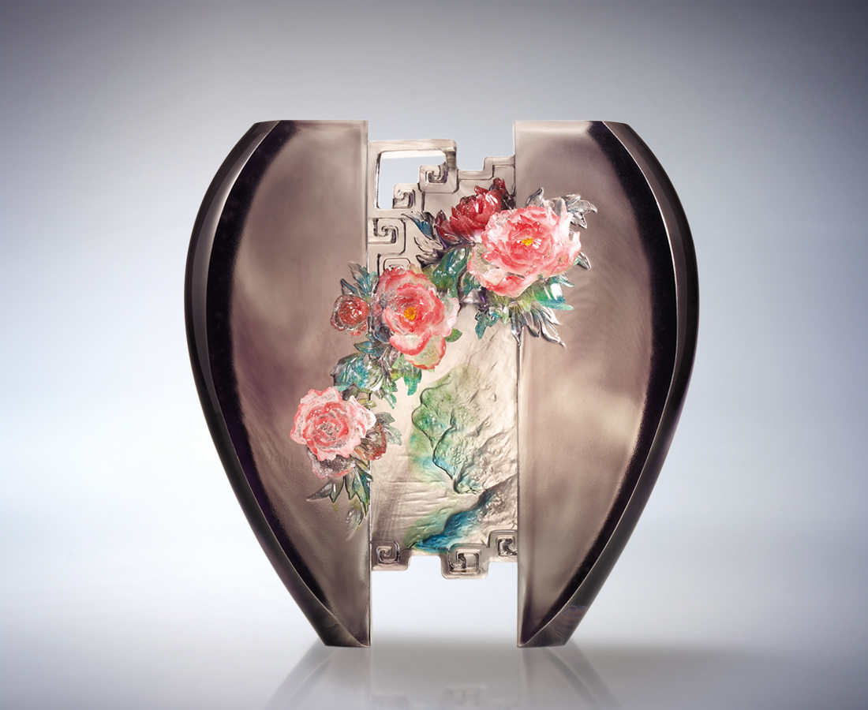
有山雄峙沉穩
有水溫柔活潑
登山臨水 剛柔並濟
更見繁華盛景
Resplendence In Dignity
Man stands like mountain, upright and tall Dignity leads like water fall Be it hard or soft, big or small Hand in hand, peonies bloom across

編號 | 1592649 | No | 1592649
名稱 | 豐華 | Name | Resplendence In Dignity
顏色 | 藍綠透紅 / 灰紅透 | Color
尺寸 | 10.8 * 24 * 24.2 | Size | 10.8 * 24 * 24.2
重量 | 8.0 | Weight | 8.0
限量 | O | Limited Edition | O
售價 | NT$ 46800 | Price | NT$ 46800
 | RMB$ 11760 |  | RMB$ 11760

