楓橋夜泊 | 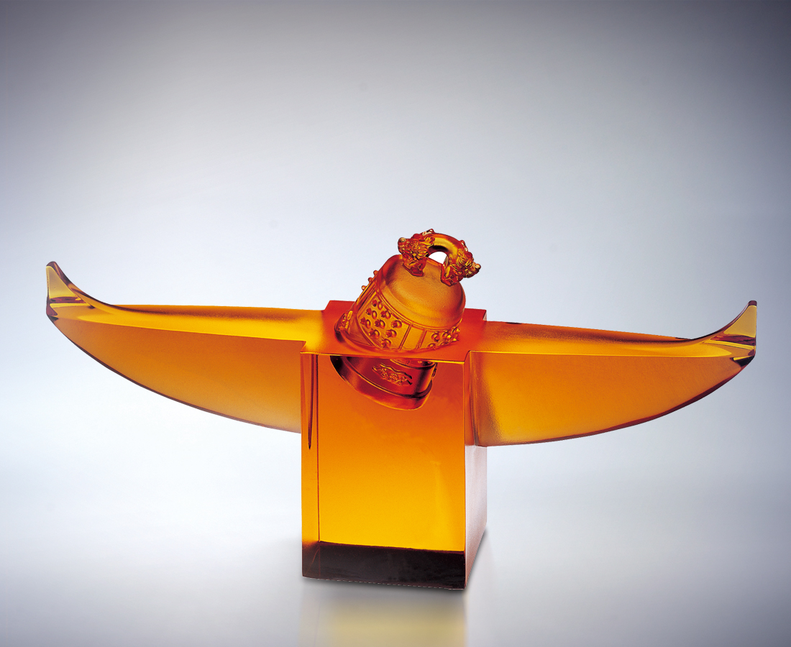
月落烏啼霜滿天
江楓漁火對愁眠
姑蘇城外寒山寺
夜半鐘聲到客船
Feng Chiao Yeh Po
Crows caw as the moon goes down from the frosty sky; The fishermen’s fires on the river light my restless sleep; At Cold Mountain Temple outside Soochow, The sound of the midnight bell carries to the resting boats.

編號 | 1590062 | No | 1590062
名稱 | 楓橋夜泊 | Name | Feng Chiao Yeh Po
顏色 | 琥 | Color
尺寸 | 6.8 * 30 * 14.5 | Size | 6.8 * 30 * 14.5
重量 | 2.25 | Weight | 2.25
限量 | O | Limited Edition | O
售價 | NT$ 18600 | Price | NT$ 18600
 | RMB$ 5088 |  | RMB$ 5088

