現代鼠 觀天想地 | 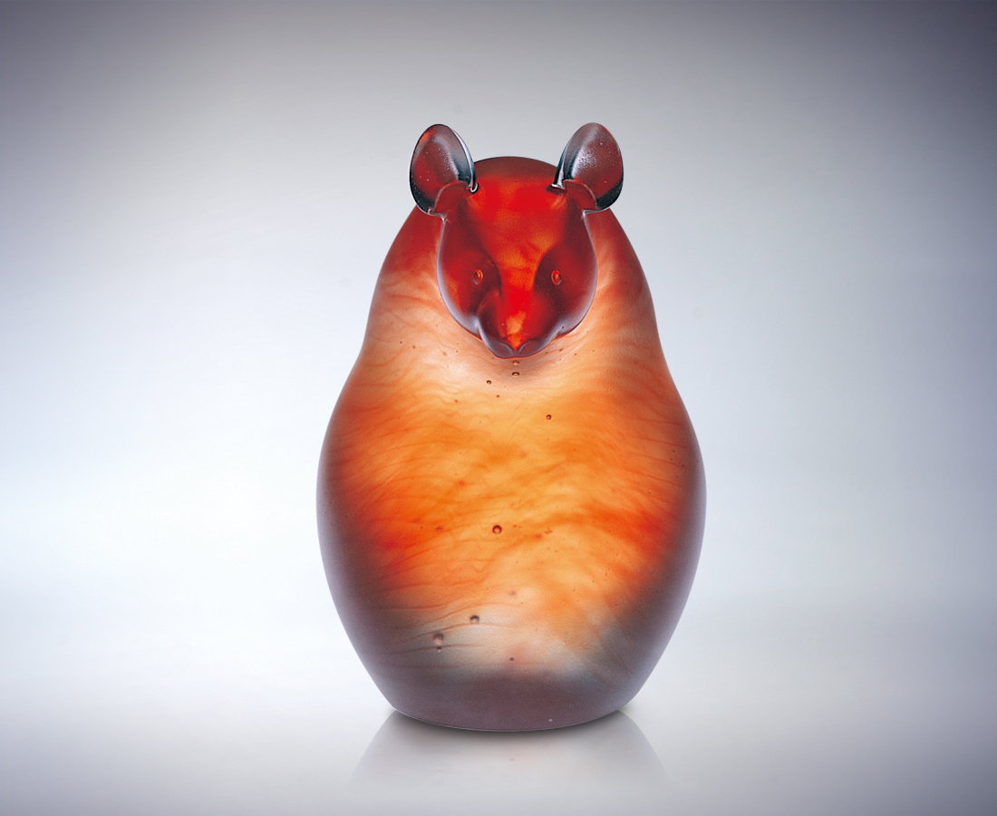
不論大小高低 不妄自菲薄
山展現永恆的意識 是
不動的堅持和自得的孤寂
它觀天想地 虛懷若谷
擁含太虛 不慌不亂
關懷世界 始終如一
山因胸懷而神聖莊嚴
Rat: Gazes at Heaven, Thinks of Earth
No matter how big, how tall Never underrates himself Mountains symbolize eternity An Immovable determination satisfied with solitude He gazes at heaven, thinks of the earth Broad minded Embodies the universe Slowly and deliberately Solicitous of the world Unchanging from start to finish Mountains majestic in their magnanimity.

編號 | 1565082 | No | 1565082
名稱 | 現代鼠 觀天想地 | Name | Rat: Gazes at Heaven, Thinks of Earth
顏色 | 紅透 | Color
尺寸 | 11.4 * 8.5 * 13.6 | Size | 11.4 * 8.5 * 13.6
重量 | 1.5 | Weight | 1.5
限量 | O | Limited Edition | O
售價 | NT$ 9980 | Price | NT$ 9980
 | RMB$ 2400 |  | RMB$ 2400

