現代猴 尋芳 | 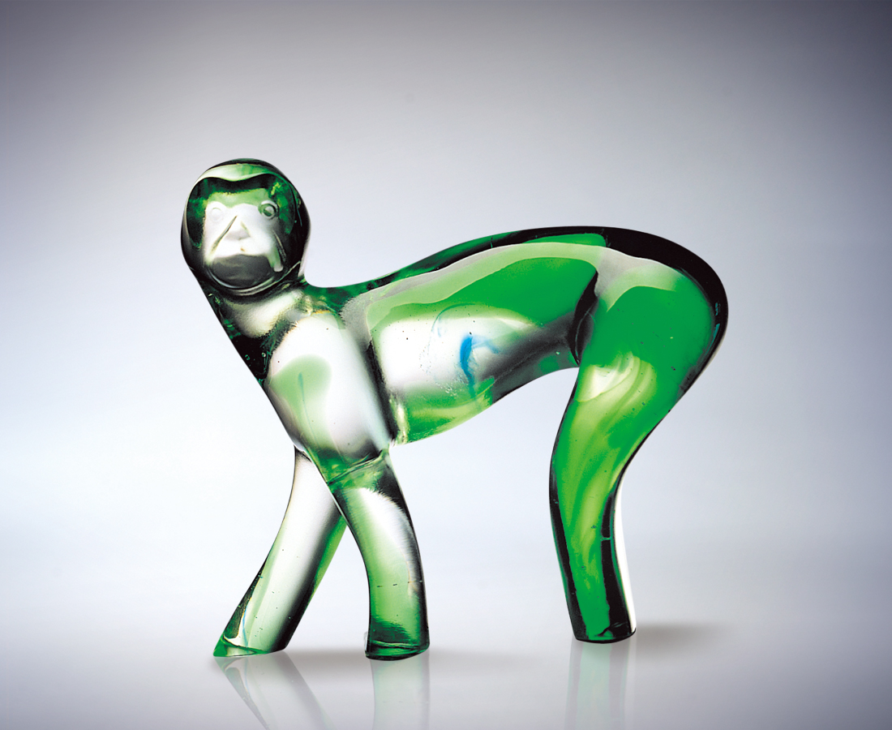
人生的路 四通八達
路旁的奇花異草繽紛
發著不同的香 將結不同的果
鐘鼎山林 各選千秋
大道的抉擇
決定一生的苦果或美味
必須一步一腳印謹慎的尋找
屬於妳的芬芳
Monkey: Seeking Fragrance
Life‘s road extends in all directions Bordered by exotic plants in rich profusion Emitting different scents Yielding different fruits In mountain and forest Each chooses his own way The road selected Determines life‘s bitterness or sweetness Seeking step by step and with great care The fragrance which belongs to you.

編號 | 1565081 | No | 1565081
名稱 | 現代猴 尋芳 | Name | Monkey: Seeking Fragrance
顏色 | 綠透 | Color
尺寸 | 15.7 * 6.2 * 14.7 | Size | 15.7 * 6.2 * 14.7
重量 | 1.5 | Weight | 1.5
限量 | O | Limited Edition | O
售價 | NT$ 11200 | Price | NT$ 11200
 | RMB$ 2400 |  | RMB$ 2400

