心寬天地寬 | 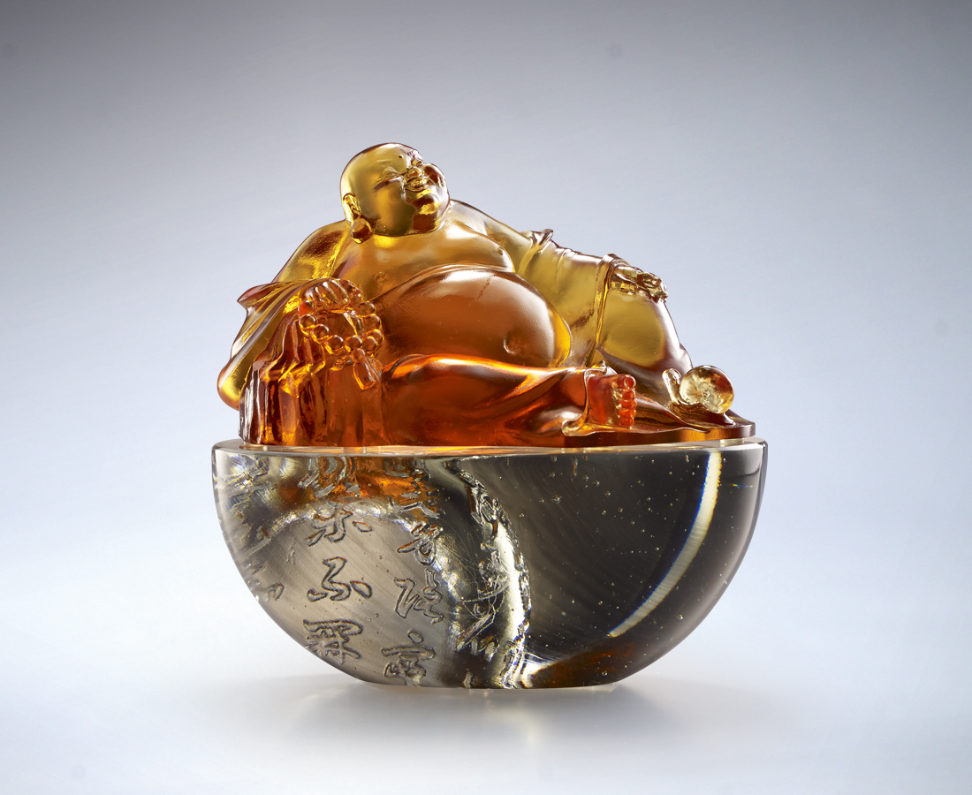
世有限 心無窮
那怕是蝸角兩端
也可以海闊天空
胸襟多大 世界多大
不拘小節 天寬地闊
大肚容四方難容事
微笑迎古今歡喜福
Maitreya
Maitreya stands for “optimism” and “tolerance” in Chinese culture. Tittot presented the positive, upward force in Chinese culture with the Maitreya sculpture along with the poem of Bai, Ju-Yi, the poet in Tang Dynasty.

編號 | 1563803 | No | 1563803
名稱 | 心寬天地寬 | Name | Maitreya
顏色 | 琥＋灰透 | Color | amber + cray, clear
尺寸 | 15 * 10.2 * 14.5 | Size | 15 * 10.2 * 14.5
重量 | 2.57 | Weight | 2.57
限量 | O | Limited Edition | O
售價 | NT$ 18800 | Price | NT$ 18800
 | RMB$ 4180 |  | RMB$ 4180

