幸福包圍 | 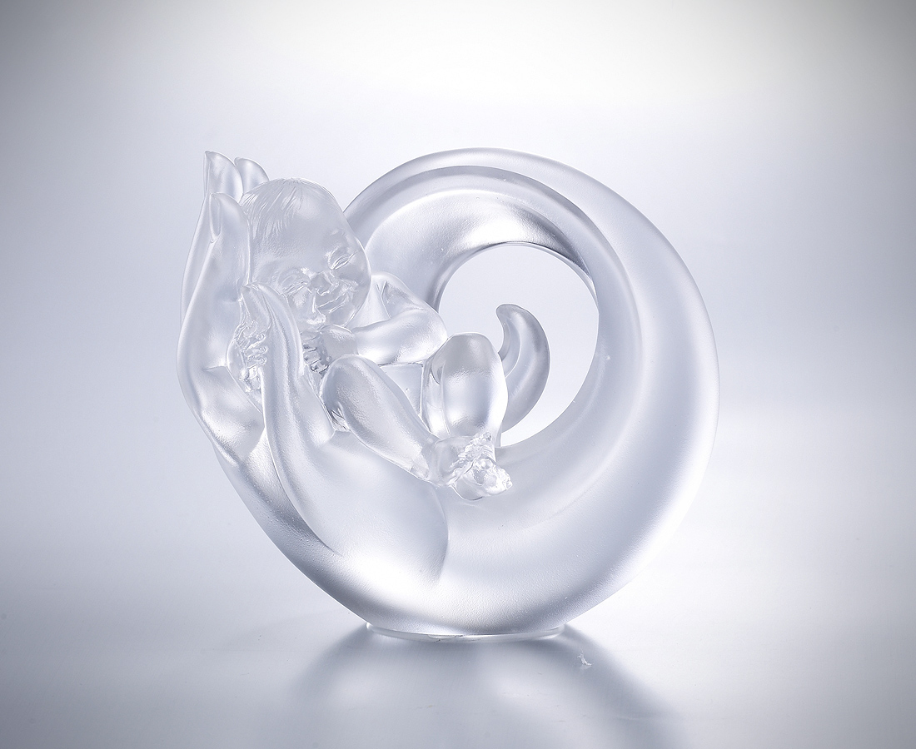
用捧在掌心的溫度
圈起無風無雨的守護
你的酣息深應我的聆聽
你的囈語牽動我的千言
謹記依偎踏實的暖意
是永遠的幸福堡壘

Surrounded by Happiness
The artwork seems to be rolling with dedicated care, like the endless love of a mother that provides caring and eternal support.

編號 | 1563304 | No | 1563304
名稱 | 幸福包圍 | Name | Surrounded by Happiness
顏色 | 透 | Color | null
尺寸 | 7.2 * 13 * 11.7 | Size | 7.2 * 13 * 11.7
重量 | 1.16 | Weight | 1.16
限量 | X | Limited Edition | X
售價 | NT$ 4880 | Price | NT$ 4880
 | RMB$ 1080 |  | RMB$ 1080

