歡添喜財 | 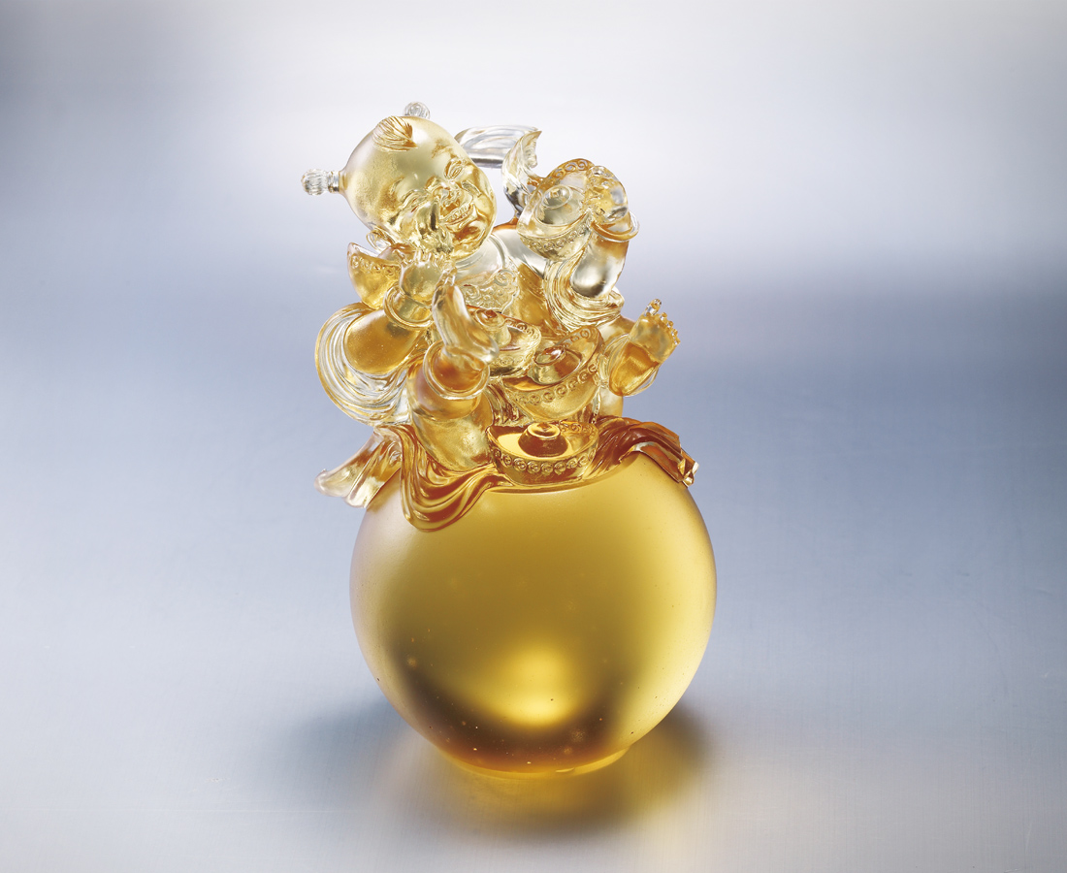
擁抱一顆歡喜心
雷電風雹 一笑置之
花開樹長 天天好日
熱情不減 信心不滅
笑開天地無窮
喜接無盡財寶
Joyful Wealth
With a heart filled with joy Laugh off adversities Flowers always blossom and trees continuously grow With ever growing enthusiasm and confidence Its laughter opens an enormous world Herald the advent of inexhaustible wealth

編號 | 1563273 | No | 1563273
名稱 | 歡添喜財 | Name | Joyful Wealth
顏色 | 金 | Color
尺寸 | 10.2 * 9.2 * 14 | Size | 10.2 * 9.2 * 14
重量 | 1.35 | Weight | 1.35
限量 | X | Limited Edition | X
售價 | NT$ 5280 | Price | NT$ 5280
 | RMB$ 1180 |  | RMB$ 1180

