合心如意 | 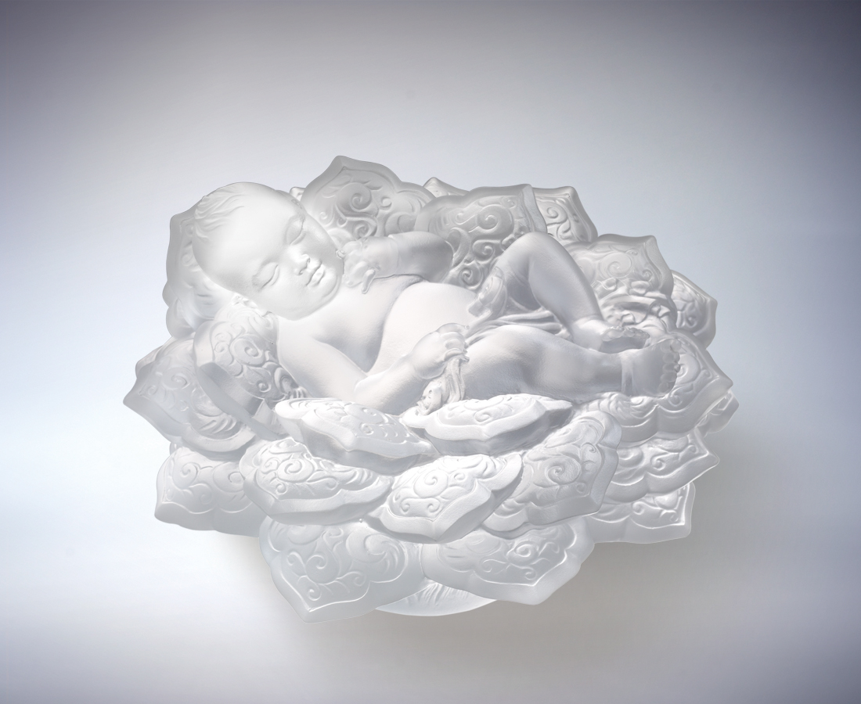
聲響亮 爛漫笑
唯你值得層層關愛
有你天天風暖花香
綿延一生稱心如意
To the Heart's Content
With your ringing voice and enchanting smile Only you are worth all the love Warm breezes and fragrant flowers are present Wherever you go To our heart's content we enjoy the sceneries of life

編號 | 1563240 | No | 1563240
名稱 | 合心如意 | Name | To the Heart's Content
顏色 | 透 | Color
尺寸 | 13.4 * 13.7 * 8.6 | Size | 13.4 * 13.7 * 8.6
重量 | 1.45 | Weight | 1.45
限量 | X | Limited Edition | X
售價 | NT$ 6680 | Price | NT$ 6680
 | RMB$ 1500 |  | RMB$ 1500

