美麗勝境 | 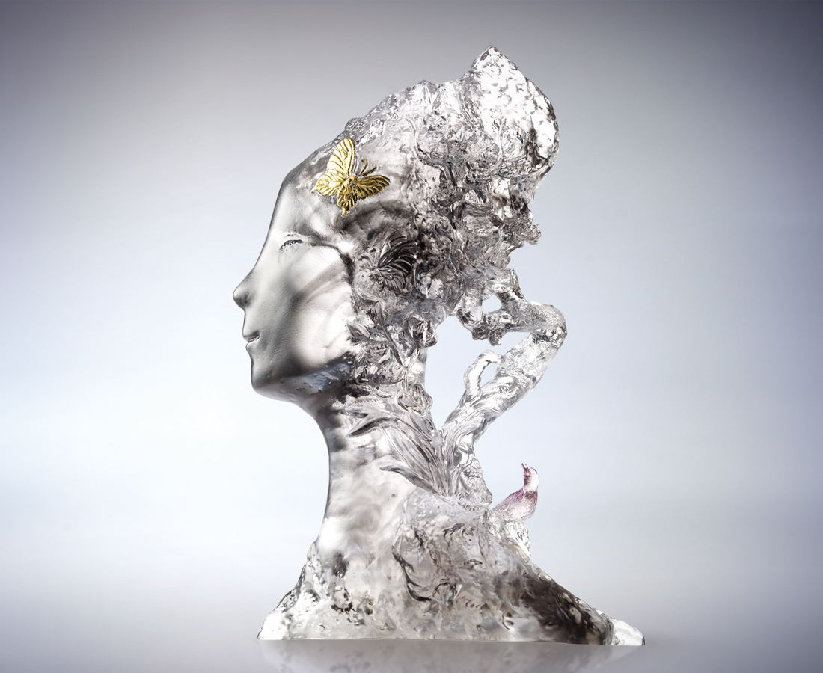
沖刷波瀾壯闊的心志
淬煉萬古流芳的意志
信心不移 勇敢不屈
理想 愈冷愈開花
視野 愈飛愈開闊
我的美麗王朝
永遠昂揚屹立
Beautiful and Victorious Scenery
Let the wave rinse the strength Let the wind effloresce the will The confidence never collapses; the brave never fears The dream of life; colder to blossom The vision of mind; higher to widen Beautiful and victorious scenery Stinging still and will be there forever spiritedly

編號 | 1562526 | No | 1562526
名稱 | 美麗勝境 | Name | Beautiful and Victorious Scenery
顏色 | 灰透紫+金箔 | Color
尺寸 | 7 * 15 * 22.2 | Size | 7 * 15 * 22.2
重量 | 3.99 | Weight | 3.99
限量 | O | Limited Edition | O
售價 | NT$ 23600 | Price | NT$ 23600
 | RMB$ 5022 |  | RMB$ 5022

