無懼 | 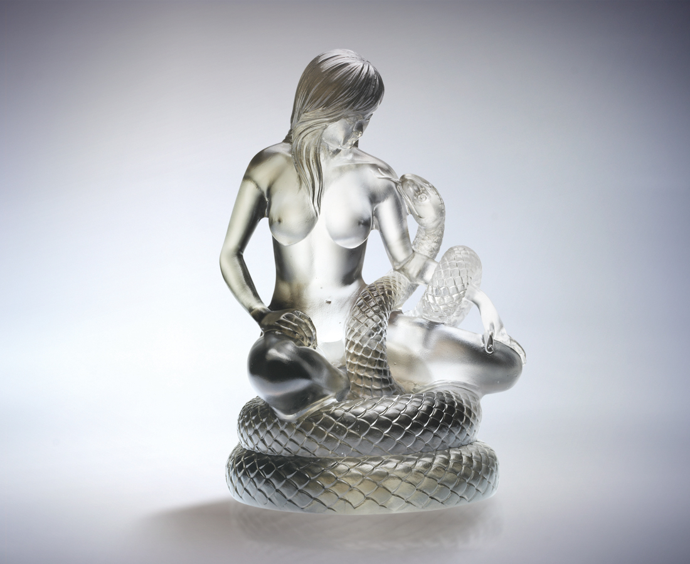
本我 無懼
順著原始的熱情
勾繞奇思異想
帶著本能的豪氣
迎接未知挑戰
靜觀於心 力道凜然
勇敢面對 操之在我
Fearless
Fear has no beginning But follows the passion And traces around creative thinking With a brave heart Face the unknown challenges courageously Look within yourself for the force And control what you bravely confront

編號 | 1562476 | No | 1562476
名稱 | 無懼 | Name | Fearless
顏色 | 灰透 | Color
尺寸 | 10.1 * 11.3 * 15.6 | Size | 10.1 * 11.3 * 15.6
重量 | 1.2 | Weight | 1.2
限量 | O | Limited Edition | O
售價 | NT$ 9680 | Price | NT$ 9680
 | RMB$ 2422 |  | RMB$ 2422

