馬到成功 | 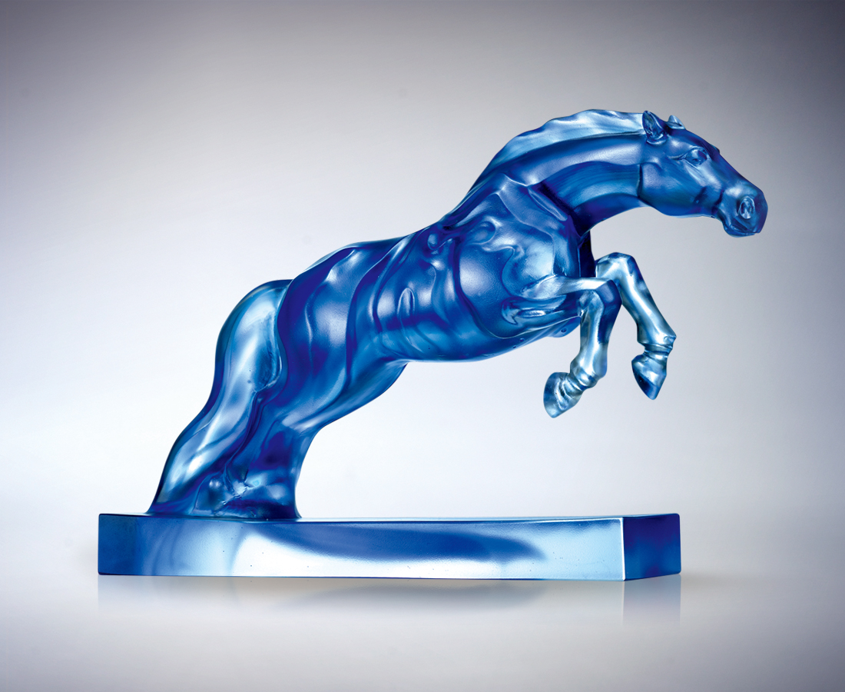
繃緊肌鍵 衝鋒陷陣
情緒高昂 全力以赴
捉準角度 高速前進
目光犀利 步調明快
行動拉近了理想願景
決心明朗了終點藍圖
重重翻越 無功不克
堂堂身手 馬到成功
Swift Success
In great strength…you charge ahead; With ardent spirits…you give it your best shot; Having found the right angle…you go forward at full speed; With keen perception…you keep up a brisk pace; Determination brings the ultimate blueprint into sharp focus: Turning over and over… you accomplish every task. Magnificently skilled…you achieve swift success.

編號 | 1560152 | No | 1560152
名稱 | 馬到成功 | Name | Swift Success
顏色 | 藍透 | Color | blue
尺寸 | 30.3 * 7.4 * 21.4 | Size | 30.3 * 7.4 * 21.4
重量 | 4.4 | Weight | 4.4
限量 | O | Limited Edition | O
售價 | NT$ 42800 | Price | NT$ 42800
 | RMB$ 9888 |  | RMB$ 9888

