希望事成 | 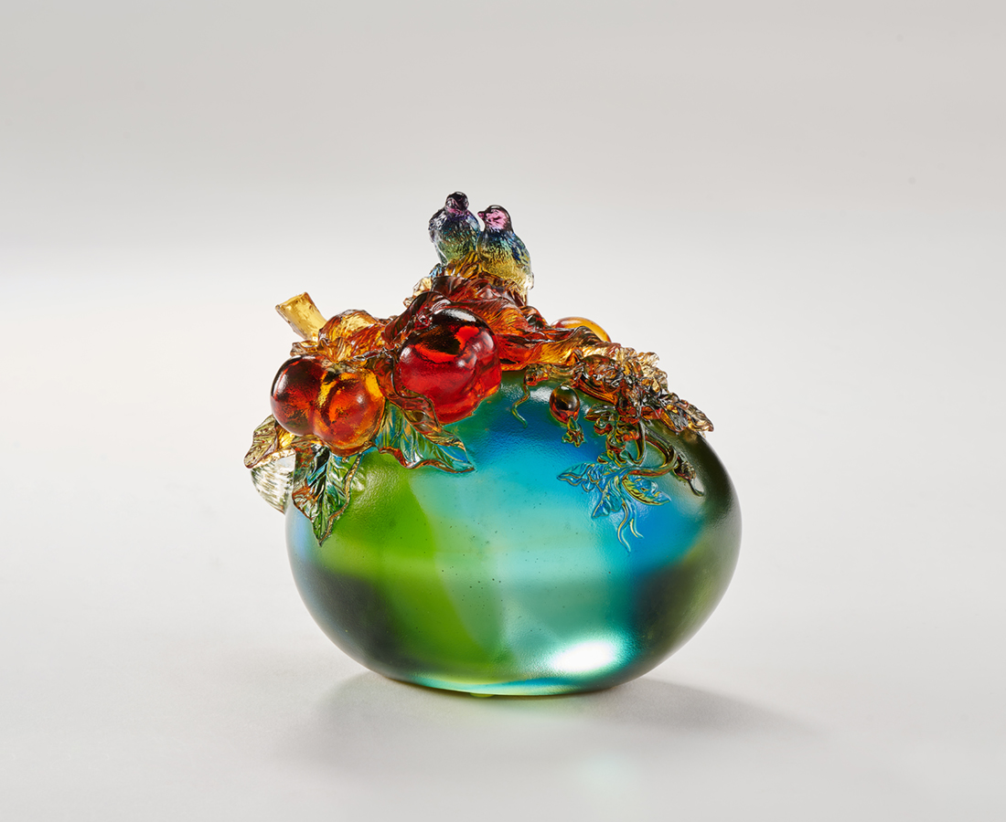
瓜甜柿美 並根同蒂
鵲鳥慕賢 風雅登臺
相遇絕非偶然
涉歷更顯圓滿
今朝有成 日遞結果
有志一同 喜蔭共享
The sweet watermelon and persimmon
The full-bodied fruit symbolizes a bountiful harvest in Chinese culture, and the round shape signifies completeness and beauty in everything. In classical creations, two kinds of fruits or plants are often combined through vines or branches to represent the fates between people and the hope that they can enjoy the tasty harvest together with their cherished ones.

編號 | 1559232 | No | 1559232
名稱 | 希望事成 | Name | The sweet watermelon and persimmon
顏色 | 藍紫綠琥透 | Color | blue, purple, green, amber, clear
尺寸 | 15 * 10.5 * 13.6 | Size | 15 * 10.5 * 13.6
重量 | 2.2 | Weight | 2.2
限量 | O | Limited Edition | O
售價 | NT$ 13800 | Price | NT$ 13800
 | RMB$ 3080 |  | RMB$ 3080

