好運滾滾 | 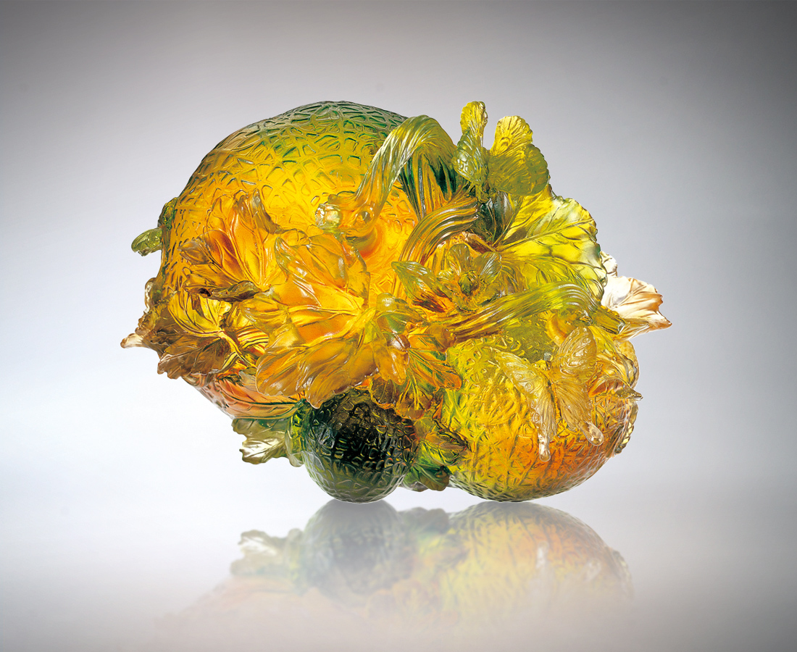
瓜瓞綿綿 從小到大
串起顆顆滾動飛舞的激情
這是成長熱情接力的軌跡
沿著甜美熟悉的成功大道
你走我跟 我轉你進
代代牽引 越滾越大
好運暢通的態勢
是參考經驗的果然
Successive Good Luck
Melons grow from small ones to big ones; Stringing passions in an endless flow; This is the track of relay-race for growth and enthusiasm; Following the sweet and familiar avenue of success; We stride forward shoulder to shoulder; Through generations of greater development; The smooth path for good luck is the inevitable outcome of reference to experiences.

編號 | 1559037 | No | 1559037
名稱 | 好運滾滾 | Name | Successive Good Luck
顏色 | 琥綠透 | Color
尺寸 | 13.5 * 15.5 * 11 | Size | 13.5 * 15.5 * 11
重量 | 2.1 | Weight | 2.1
限量 | O | Limited Edition | O
售價 | NT$ 13800 | Price | NT$ 13800
 | RMB$ 3788 |  | RMB$ 3788

