聰明伶俐 | 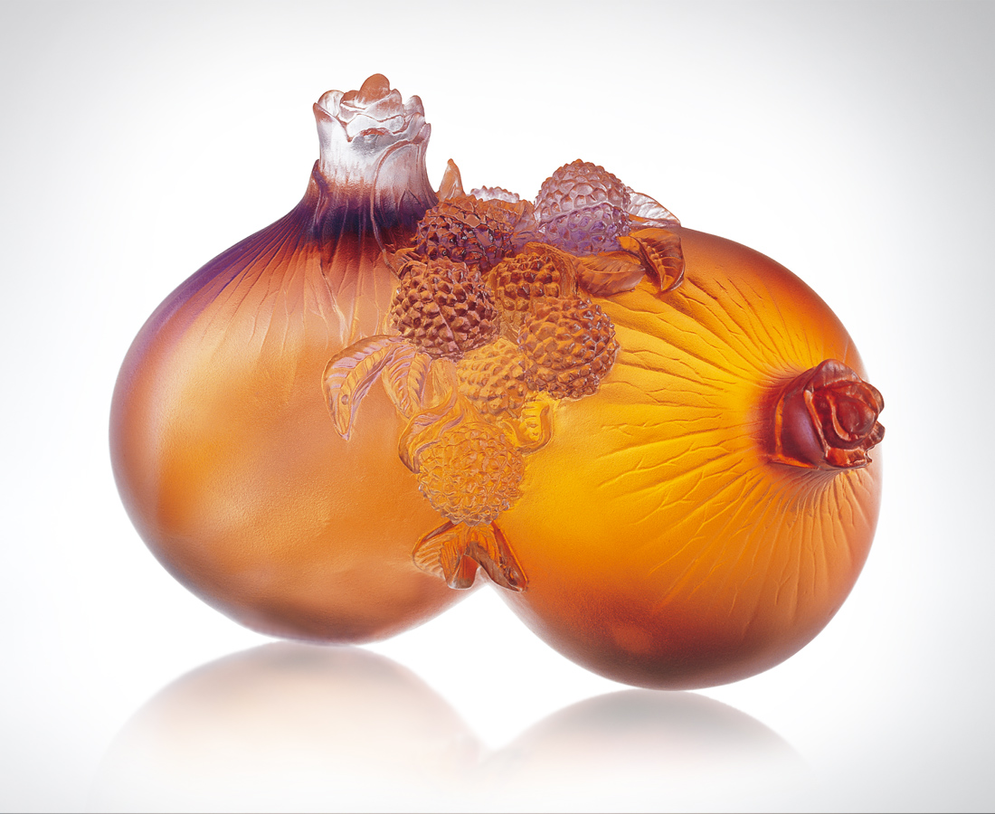
地底的飽實
是層層廣納福份的沉著修持
成竹在胸 顆顆沉穩聰慧
空中的豐美
是不畏風吹雨打的艱辛歷練
見多識廣 粒粒應變得體
聰明伶俐 成熟達練
是才智和經驗的果然
Wisdom and Cleverness
The solid underground is the composed cultivation of multi-happiness; Full confidence is the collected wisdom; The richness and beauty of the sky are the arduous experiences of standing up to the wind and rain; Extensive knowledge makes every effort apt; Wisdom, cleverness and proficiency are the inevitable outcome of intelligence and experience.

編號 | 1559012 | No | 1559012
名稱 | 聰明伶俐 | Name | Wisdom and Cleverness
顏色 | 琥紫透 | Color
尺寸 | 6.8 * 11.4 * 7.8 | Size | 6.8 * 11.4 * 7.8
重量 | 0.73 | Weight | 0.73
限量 | O | Limited Edition | O
售價 | NT$ 4660 | Price | NT$ 4660
 | RMB$ 1188 |  | RMB$ 1188

