快樂滿分 | 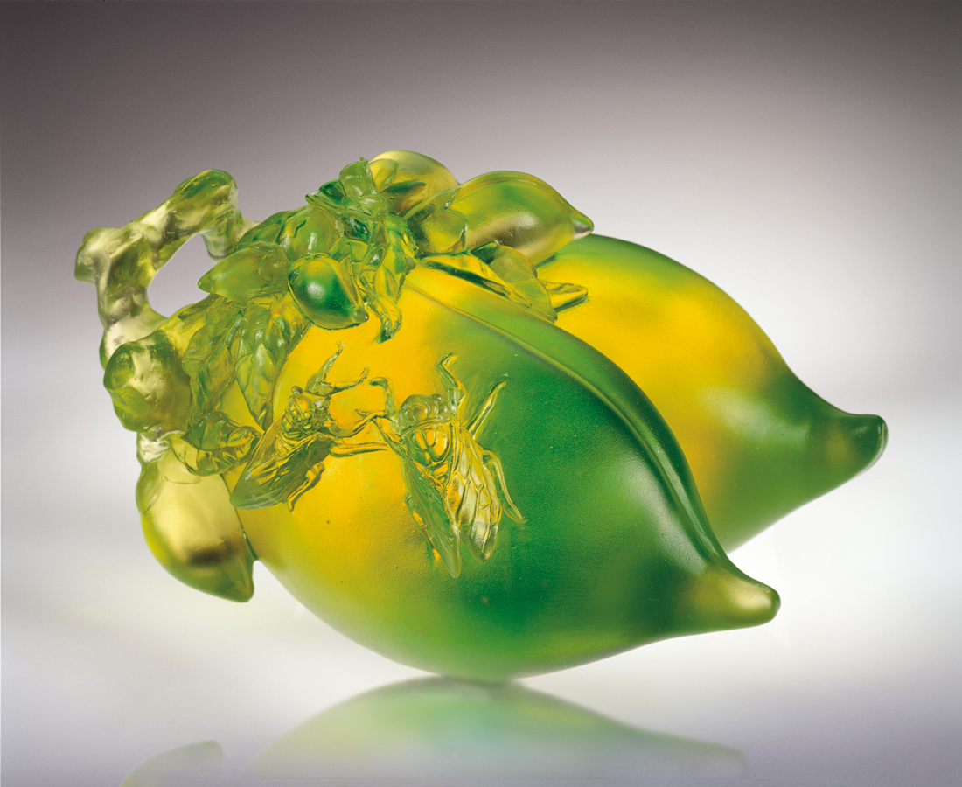
蟬鳴喧騰夏天迴盪的熱切
仙桃交換成熟豐碩的鮮美
適時洞悉現實處境
不斷回味往事歷練
藉告知分享傳承
預約來日的圓滿
健康快樂滿分是
準確把握訊息的果然
Perfect Happiness
Hot summer is permeated with high-sounding cicadas; Peaches symbolize the freshness and beauty of maturity and fruitfulness; Perceiving the real situation at an appropriate time; Recalling experiences of the past; Informing the share and inheritance of achievements; Foretelling the perfection of the future; Perfect health and happiness are the inevitable outcome of getting accurate hold of information.

編號 | 1558086 | No | 1558086
名稱 | 快樂滿分 | Name | Perfect Happiness
顏色 | 金綠 | Color
尺寸 | 13.2 * 17.2 * 9.8 | Size | 13.2 * 17.2 * 9.8
重量 | 2.5 | Weight | 2.5
限量 | O | Limited Edition | O
售價 | NT$ 11860 | Price | NT$ 11860
 | RMB$ 2688 |  | RMB$ 2688

