桃李芬芳 | 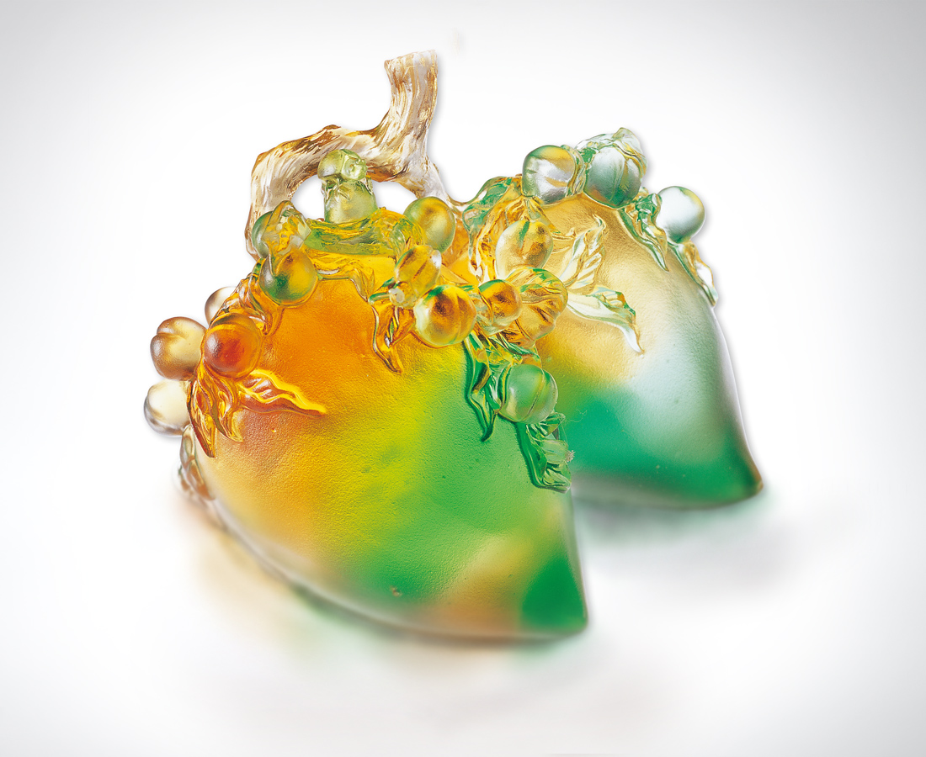
事業版圖的擴張
文化現象的成形
需要時間 需要人才
時間累積熟練智能
人數密佈普遍關注
豐碩精幹歷練的全面專才
培養食髓知味的熱愛投入
桃李芬芳 飽滿量大
是萬古流芳志業永續的果然
A Plentiful Harvest of Peaches and Plums
The expansion of career and the formation of cultural phenomena require time and talents; Time serves to accumulate proficient wisdom; Universal concern is exerted over versatile talents with rich experiences among so many people; Enthusiastic efforts are made in bringing up them; Outstanding talents can give full play to their role; They are the inevitable outcome of sustainable development through the ages.

編號 | 1558082 | No | 1558082
名稱 | 桃李芬芳 | Name | A Plentiful Harvest of Peaches and Plums
顏色 | 琥綠透 | Color
尺寸 | 10.5 * 10.5 * 7.6 | Size | 10.5 * 10.5 * 7.6
重量 | 0.82 | Weight | 0.82
限量 | O | Limited Edition | O
售價 | NT$ 4860 | Price | NT$ 4860
 | RMB$ 1488 |  | RMB$ 1488

